

Preschool

PARENT-STUDENT HANDBOOK
2025-2026

Ms. Mary Ann McFarland, Principal, Central Administrator
Fr. Daniel Schaicoski, OSBM, Director

29500 Westbrook
Warren, Michigan 48092
Phone: 586-574-2480 Fax: 586-574-3497
www.icschoolswarren.org

WELCOME!

Welcome to Immaculate Conception Preschool. We offer both full and half day programs for three and four year olds. We’re glad you’re here and we look forward to working together with you so your child will have a wonderful year filled with love, security, and success.

Preschool is an important time in your child’s life. We believe our program offers a positive, loving, and nurturing environment. During the year, your child will be encouraged to experiment, explore, create, and discover. Learning is fun! Mistakes are O.K. We are all learning. Each child is a unique and special gift from God.

MISSION STATEMENT

It is our belief at Immaculate Conception that each child is a special gift from God, born with unique talents and abilities. It is our job as teachers to nurture these talents and abilities so that our students will grow and become all that God wants them to be and be prepared for the future.

It is also our desire to partner with the parents of our students in order to provide assistance, support and insight into their child’s development. Our school promotes the development of self- confidence in each child within an atmosphere where physical, social, emotional, intellectual and spiritual development will occur.

The principal and/or director has the authority to interpret or clarify any policy and/or terminology inadvertently omitted from this handbook. Updates may occur as required by law or as necessary.

ABOUT OUR PRESCHOOL PROGRAM

HOURS OF OPERATION
Main office hours are 7:45AM to 3:15PM and messages may be left before or after office hours at (586) 574-2480.

If a consultation with the director or teacher is desired, an appointment is necessary. Please call to schedule a date and time.

CONTACT INFORMATION

PRESCHOOL STAFF

Ms. Olha Muravka, Preschool Lead Teacher
E-mail: omuravka@icschoolswarren.org

Mrs. Svitlana Demianchuk, Preschool Lead Teacher
E-mail: sdemianchuk@icschoolswarren.org

Preschool Absences/Illness Hotline: (586) 574-2480
(before and during school hours)

IMMACULATE CONCEPTION SCHOOLS MAIN OFFICE STAFF

Father Daniel Schaicoski, OSBM, Director
Ms. Mary Ann Gruda, Principal, Central Administrator
Ms. Anita Colo, Assistant-Principal
Ms. Snizhana Kreshchuk, Secretary

Address 29500 Westbrook Ave, Warren, MI 48092 USA
Main Office 586.574.2480
Fax 586.574.3497
Website www.icschoolswarren.org
Facebook https://www.facebook.com/www.icschools2015
Main Office Email ic-office@icschoolswarren.org

*Preschool Licencing Notebook is available to parents
ADMISSION AND WITHDRAWAL POLICIES

CLASSROOMS AND RATIOS
The ratio of staff to children is based on State of Michigan Licensing requirements by children’s age.

- Preschool has a 1:10 ratio for students three (3) years of age

- Pre-kindergarten has a 1:12 ratio for students four (4) years of age

ADMISSION
All children entering our program must be toilet trained. Disposable pull-up undergarments are not permitted.

Please also note the following:
- To be enrolled in our Preschool program, children must be at least two years (2) and nine months (9) by their first day of school. Parents must complete and return an admissions waiver.
- All students will be sorted by date of birth (birthday) for class placement.
- IC Schools Administration will determine final classroom placement and teacher assignment.
- Students enrolling after March 31 will repeat that level the following year.
- A seat will only be reserved for admission (e.g. due to not yet meeting age requirements, etc.) if the non-refundable registration fee is paid AND tuition payments are made during the time the child is not yet able/eligible to attend.

Children are selected for enrollment on a first-come-first-serve basis when they submit an application (with the required fee) for vacancies within the appropriate age grouping. Occasionally, there is a waiting list organized by the date the application was received and the age of the child. Children meeting the age requirements will receive first priority when openings occur. Otherwise, the date of application will receive first preference.

Applications will be reviewed by the Administration and faculty before children are placed in the appropriate classrooms. Students turning five (5) years of age by the following September 1st will be eligible for Kindergarten regardless of current class placement.

All enrollment forms should be completed, signed and returned as soon as possible. State of Michigan licensing regulations require that emergency and immunizations records be completed and on file by the first day a child is in attendance without a parent. Medical information, including the health record, must be on file no more than 30 days after the first day of attendance. Emergency information cards must be updated annually.

POTTY TRAINING POLICY
All children entering our Early Childhood Program (Preschool AND Kindergarten) must be potty-trained. Disposable pull-up undergarments are not permitted.

While we understand occasional help may be required for snaps, buttons, and zippers, children must be able to independently take care of their personal bathroom needs. We also understand that accidents will happen, and staff will help children change into dry clothing when necessary. If accidents occur on a regular basis, it will be clear that the child is not yet fully toilet trained. Should this happen, the child will need to be withdrawn from the program until he or she becomes fully trained.

Why do children have to be potty-trained before they begin preschool?
- IC Preschool and Kindergarten are school settings, not daycare centers.
- There are strict standards for changing and disposing of wet or soiled diapers.
- The classrooms are not equipped for diaper changing.
- When an adult is busy changing a child’s diaper or soiled clothing, it is taking away from learning time for all students and it removes at least one adult from the direct supervision of and interaction with the rest of the class.

We understand that even potty-trained children will occasionally have toileting accidents. By definition, "accidents" are unusual incidents and only happen infrequently. In these instances, staff will help children to change their clothes, encouraging independence as much as possible.

Students with recurrent toileting accidents may be asked to remain home and/or withdraw from the Program, in accordance with these policies.

- First Occurrence: First accident, the child’s clothes will be changed in school, if possible. If teachers are unable to change the child’s clothes, a parent will be called to bring a change of clothes.
- Second Occurrence: Same as above plus parent will be called with a warning should another incident occur, the student will have to stay home for re-training.
- Third Occurrence: The child must stay home for a 2-week period to re-train. Tuition must continue to be paid to maintain the child’s seat.
- Fourth Occurrence: Steps 1-3 will be repeated with the understanding that if the child demonstrates they are not fully potty-trained, they will be asked to withdraw from the program.

Along with regularly scheduled bathroom breaks, IC Staff will ask your child many times throughout the day if s/he needs to use the bathroom. A staff member will assist children as needed, but children should be able to complete toileting activities independently. This is an issue which protects all concerned.

Please dress your child in clothing that can be undone and changed easily. Please send a complete change of clothes appropriate for the season. These will be left at school in case of accidents, and returned as needed and/or at the end of the school year. Parents will be notified if a child has a toileting accident.

Every child enrolled in Immaculate Conception’s Preschool (and Kindergarten) must be able to:
- Communicate to the teachers that s/he needs to go to the restroom before they need to go.
- Alert him/herself to stop what s/he is doing, to go and use the bathroom.
- Pull down his/her clothes and get them back up without assistance.
- Wipe him/herself after using the toilet. (With minimal assistance for 3 year olds.)
- Get on/off the toilet by him/herself.
- Wash and dry hands.
- Postpone going if they must wait for someone who is in the bathroom or if we are away from the classroom.
- Awaken during nap time should they need to use the bathroom.

ENROLLMENT FORMS
The enrollment packet should be completed before the first day of school.

On the first day of attendance, children must have a Child Information Record and Immunization Record completed and on file. This is a licensing regulation and cannot be waived.

Additional registration forms/information required include:

- Completed Child Information Record
- Completed Health Appraisal form including:
- Health History completed by parent (Section I)
- Physical Exam, dated within the preceding year (Section II)
- An up to date Immunization Record (Section III) or State of Michigan Immunization Waiver
- Recommendations (Section IV)
- Notification of allergies or other special circumstances or needs
- Signed “Photo Release Form”
- Signed “Preschool Options” form
- Signed “Topical Medication Permission and Instructions” form
- Signed “Licensing Notebook Acknowledgement” form
- Signed “Tuition Policy Agreement”
- Signed “Release for Dispensing of Medication” form, if needed
- Attendance Waiver Request, if needed (If your child will be enrolled in a classroom for older students)
- Changes in licensing, accreditation, or law may require additional forms be completed

GENERAL SCHOOL HOURS
The school day begins at 7:40A and ends at 3:15P. School Office hours are 7:30A-3:30P. Students should arrive by 7:40A and will be admitted through their designated class entry/door. All students should leave the school promptly after dismissal at 3:15 through their designated class exit/door.
For the safety and security of our faculty and staff, NO STUDENTS OR PARENTS MAY ENTER THE SCHOOL BUILDING BEFORE 7:40A OR AFTER 3:15P WITHOUT AN APPOINTMENT. Students and parents will not be admitted to the building – including classrooms - to retrieve lost or forgotten items such as homework or textbooks. Parents and students may not “cut through” the building in order to meet teachers, other students, etc.

ATTENDANCE OPTIONS
Full-time and part-time options are available.

- Full-time is defined as care that is provided five full days per week from 7:45AM to 3:15PM

- Part-time is defined as care that is provided three full days per week or five half days (mornings) per week from 7:45AM to 11:30AM

Immaculate Conception Preschool does not offer the following schedules:

- Just one or two days per week

- Just afternoon care

- "Drop-in" care

WITHDRAWAL AND OPTION CHANGES
Advance notice must be provided to the Director prior to withdrawal and approval may be needed for option changes depending on available space in the classroom. A withdrawal form or option form must be completed and signed by the parent/guardian and returned to school for our records.

Please refer to the TUITION AND FEE POLICIES for details regarding tuition changes.
Students with a part-time schedule of three full days may be permitted to attend special event days (i.e. First day of school Ringing of the Bells ceremony, Field Day, St. Nicholas Christmas Program) by switching a regularly scheduled day, at the discretion of the Director. Advance permission must be given before any child is dropped off at school.

Immaculate Conception Preschool does not offer tuition credit for sick days, holidays, unexpected closures, snow days, or vacation days. If a family must be absent for an extended period of time, they may choose to continue to pay tuition to hold the spot, or officially withdraw and reapply when ready if there are still vacancies in the class. Tuition credit for extended leave may be granted in rare circumstances at the discretion of the school administrator.

DISENROLLMENT
A family may be asked to leave Immaculate Conception Preschool for any of the following reasons, although there may be others. Each disenrollment/dismissal will be handled on an individual basis by the Director and school administrators.

- The child or parent(s) are not adjusting to Immaculate Conception Preschool. (i.e. incomplete toilet training)

- The parent(s) or child is disrupting the safety or well-being of children and/or staff.

- Parents have not completed and returned required enrollment forms promptly.

- Nonpayment or habitual late payment of tuition or fees.

- Habitual late pick-ups.

COMMUNICATION
IC utilizes several methods to communicate with parents and students. Parents and students are responsible for accepting invitations and/or signing up to the platforms listed below and reviewing information shared. If you do not receive messages via a platform, please contact the Main Office immediately. NOTE: Foreign email addresses ending in extensions such as .ru may not receive messages from our provider. We suggest families use an American-based email provider such as @yahoo.com, @gmail.com, @outlook.com, etc.

SPECIAL NOTE: If you wish to contact a teacher, please use your dedicated classroom platform (DOJO, Google Classroom) or email them directly. Remember, teachers may not be able to get back to you during instruction time. We thank you for your patience! Teachers will respond within two business days. For items that need immediate attention, please call the Main Office, 586.574.2480.

- Class DOJO: Connects teachers and families through communication features, such as a feed for photos and videos from the school day, and messaging that can be translated into more than 35 languages. Each teacher has their own classroom code which they provide to parents. Accessible online and via the app. Do not use the paid version of Dojo.
- Email, ALL FAMILIES (PS, K-8): All IC Schools faculty and staff are assigned school email addresses for school use ending in @icschoolswarren.org. Please be sure to regularly check your email for messages from the Main Office, your child’s teachers, etc.
- MailChimp, ALL FAMILIES (PS, K-8): Email program IC Schools uses to communicate with parents, particularly the weekly eNewsletter. Emails contain active links, graphics, PDFs, etc. Emails from MailChimp are labeled from “Immaculate Conception Catholic Schools”. Please add the email address to your contacts list. Be sure to check your junk/spam folder if you do not see it in your inbox.
- Remind App, ALL FAMILIES (PS, K-8): Communication platform that helps educators and moderators reach students and parents via text messages. Data rates and text message fees may apply. You may opt out at any time; however, you will no longer receive real-time updates about school closures, updates, etc. These communications are general reminders and sudden alerts (practice is cancelled, no school due to weather, special instructions for events, volunteer opportunities, etc.) that are specific to Immaculate Conception Ukrainian Catholic Schools families. Each family is assigned to a group according to the CHILD’s LAST NAME and parents should only join ONE GROUP per family. Moms and dads/guardians are both invited to join!

TUITION AND FEE POLICIES
Tuition is paid to secure the space within the preschool program and is due for each enrolled child. There is no tuition credit for sick days, holidays, unexpected closings, or vacation days. A tuition policy agreement must be signed and returned to the office.

TUITION RATES
Immaculate Conception Preschool has a non-refundable registration fee per student. Before May 30, 2025 Non-Refundable Application fee: 1 child - $200 fee; 2nd child - $200 fee; 3rd and more children - NO additional fee (cash or check payable to "IC Schools")
After May 30, 2025 Non-Refundable Application fee: 1 child - $400 fee; 2nd child - $400 fee; 3rd and more children - NO additional fee (cash or check payable to “IC Schools).

Tuition rates are set yearly. Please see the Main Office for information.

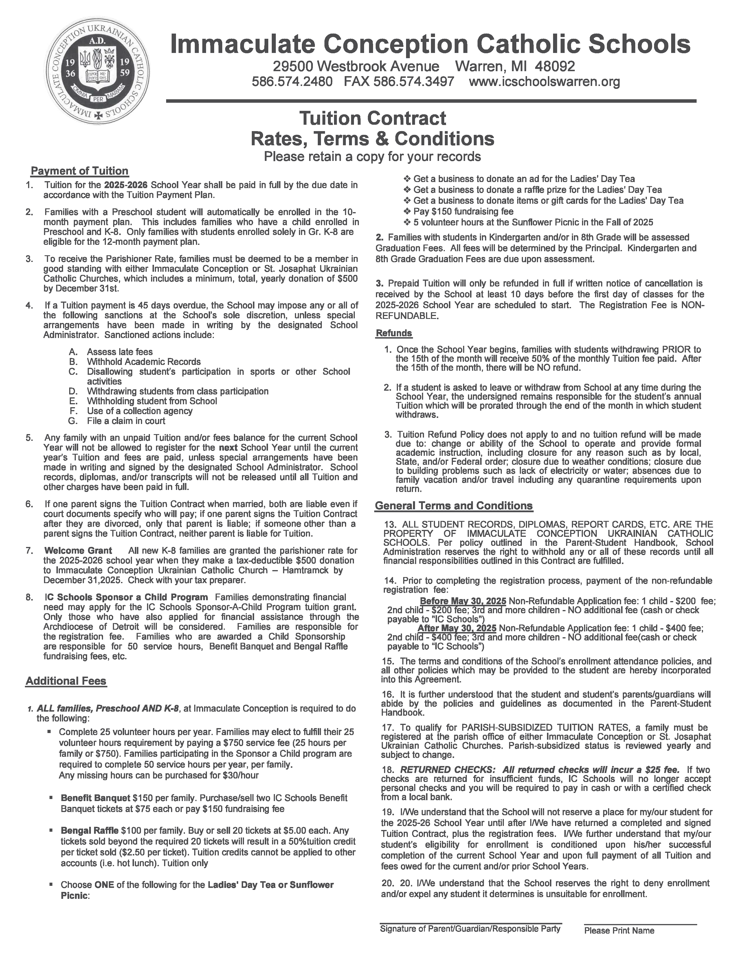

PAYMENT PLAN
Tuition is divided into 10 monthly payments due the first day of each month beginning July 1st and ending April 1st. Only families with a child also enrolled in the grade school/academy may choose to participate in the 12-month plan* which begins July 1st and ends June 1st. A coupon payment booklet will be issued to each family from the main office. Payments may be dropped off in the office or mailed to the school.

2024-2025 Tuition Payment Schedule

- Monday July 1, 2025
- Thursday August 1, 2025
- Sunday September 1, 2025
- Tuesday October 1, 2025
- Friday November 1, 2025
- Sunday December 1, 2025
- Wednesday January , 2026
- Saturday February 1, 2026
- Saturday March 1, 2026
- Tuesday April 1, 2026
- Thursday May 1, 2026
- Sunday June 1, 2026

LATE TUITION POLICY
All balances must be paid in full before a child can be enrolled in the next program year. The following actions will apply:

A late fee of $25 will be assessed if tuition payments are not received by the first (1st) of each month.

Tuition payments that are forty-five (45) days overdue may result in:
- Assessment of late fees
- Withdrawal of student from class participation
- Withdrawal of student from school
- Use of a collection agency
- File of a claim in court

EARLY WITHDRAWAL
Students leaving the school prior to the 15th of the month will receive a refund of 50% of the monthly tuition fee already paid.

Students leaving after the 15th of the month will not receive a refund.

Students leaving with tuition pre-paid will receive a refund based on the number of school days attended.

SIBLING DISCOUNT
If a family has two or more students registered at Immaculate Conception Schools, there is a 5% discount for the tuition of the preschool student only.

REQUIRED FUNDRAISING
As part of school-wide fundraising efforts, all families at Immaculate Conception Schools, Preschool and Grades K-8, are required to purchase or sell 2 IC Schools Banquet tickets at $75/ea or $150.00. Also, all families, Preschool and Grades K-8 are required to sell or purchase a book of Bengal Raffle tickets, totaling $100.00. Please see the Main Office for more details.

RETURNED CHECK POLICY
All returned checks will incur a fee of $25. If two checks are returned for insufficient funds, the school will no longer accept personal checks and tuition must be paid in cash or with a certified check from a local bank.

PARTICIPATION FEES POLICY
Any activity-specific fees must be paid in EXACT CHANGE. Teachers cannot provide change. This includes: book fair, book orders, hot lunch, field trips, aftercare, bake sale, "spending money", etc.

ATTENDANCE
Preschool begins at 7:45AM. Parents should report with their child to the designated drop off area outside the “big gym” and wait with their child until the child is admitted to the building. A staff member will walk them to class. All children will be signed in at drop-off time and signed out at pick-up time.

Children should arrive no later than 7:45AM. After 7:45AM, children should be dropped off and signed in at the Main Office. A staff member will escort the child to class. The teachers set aside this time each morning for welcoming children and easing their transition into the classroom. It is difficult for staff members to leave scheduled classroom activities in order to greet children and address separation issues after this time. Late drop-off is disruptive to the children and often has adverse effects on the program quality for those involved. If your child needs to arrive later due to unavoidable situations, we ask that you let us know in advance.

LATE DROP-OFF POLICY
Staffing will be assessed prior to 8:30AM. Therefore, additional lunch time staff may be rescheduled or reassigned based on the number of children who are physically present at that time. Staff ratios must be in compliance with State of Michigan licensing regulations, and children who arrive after 8:30AM without prior notification may not be accepted into the preschool for that day.

ABSENCES AND ILLNESSES
Each day a child will be absent on a scheduled day, parents/guardians should inform the Main Office by 8:00AM.

Please leave a detailed message if your child has a contagious illness and may have been infectious during the school day. State of Michigan licensing requires that written notification is sent home to inform all families of possible exposure to contagious diseases; for example, conjunctivitis (pink eye), lice, and chicken pox. Weekly reports of communicable diseases also must be filed with the Macomb County Health Department.

After a contagious illness, clearance from a doctor is required for re-admittance to class.

If children are showing signs of illness in the morning, it is wise to keep them home. This will avoid exposure to the other children and staff, and will reduce instances of a child becoming ill in the classroom.

Please see the HEALTH CARE PLAN section for more details.
UNIFORM
All students at Immaculate Conception Elementary School and Academy should dress neatly and in accordance with the school rules governing proper attire. Blouses/shirts are to be completely tucked into waistbands. Students not in accordance with the dress code will receive a violation, which will be sent home to be signed by the parent. Repeated violations will result in demerits and detention.

Preschool & Kindergarten
- Solid navy-blue shorts or sweatpants. No denim, stretch pants or leggings are allowed.
- Solid gray short or long-sleeved T-shirt with the IC school logo (2024/25 version or new version from Emilia’s)
- Sweaters – Solid navy-blue or white sweater or sweater vests may be worn.
- Sweatshirts/hoodies- Navy-blue (2024/25 version or new gray version from Emilia’s) with school logo, official spirit wear sweatshirts/hoodies, OR solid navy-blue sweatshirts are allowed in cold weather.
- Shoes - Solid-colored dress shoes OR solid colored tennis shoes are worn with school uniforms. Any logo (Ex. Nike ‘swoosh’, Adidas stripes, Under Armour, etc. but not limited to, needs to be the same color as the shoe. Black shoes with a black Nike ‘swoosh’ are acceptable. Black Nike shoes with a white ‘swoosh’ are NOT acceptable. Acceptable shoe colors are gray, brown, white, navy-blue, or black. Velcro or slip-on, no ties/shoelaces. All shoes must have a non-marking sole. Shoes must not light up or make sounds. Higher heels, platforms, mules, cloth, backless shoes or sandals are not allowed. Boots are not to be worn in class. If a student wears them to school, they must change into school shoes for classes; during cold weather, they may wear boots during outdoor recess.
- ATHLETIC SHOES/CLEATS – NO athletic shoes/cleats may be worn on campus during school hours. This includes recess and gym class.
- Fake nails, bright-colored nail polish/designs, and make-up are not allowed.
- Jewelry is restricted to one small pair of earrings or simple necklace. NO WATCHES.
- Girls’ hair must be neat and well groomed. Hair must not be a distraction. Therefore, bleached or frosted hair, bizarre hair colors, or hairstyles (such as “spiked hair”, “Mohawks,” or shaved heads) are not permitted.
- Boys’ Hair - Hair must be neat, clean, trimmed, and well-groomed. Hair past the collar must be pulled back into a bun.

Spring/Summer Uniform
When temperatures reach 80F or higher, students in grades 1-8 may wear uniform shorts. Solid navy-blue uniform shorts (should be no more than three inches above the knee) may be worn with school polos (2024/25 version or new version from Emilia’s) and school shoes. Kindergarten and Preschool students may wear gym uniforms, navy-blue jersey knit shorts.

- NO SHORTS MAY BE WORN FRIDAYS DUE TO DIVINE LITURGY.
- NO STRETCH PANTS/SHORTS, BIKE SHORTS, SPANDEX SHORTS/PANTS OR LEGGINGS.
- NO ATHLETIC SHOES/CLEATS may be worn on campus during school hours. This includes recess and gym class.

Uniform Code Violations
All students are expected to be in accord with the uniform code on a daily basis. Repeated violations will result in the following:

UNIFORM VIOLATIONS FOR PRESCHOOL
FIRST VIOLATION: Teacher informs parent of violation and of the consequences following a second occurrence

SECOND VIOLATION: Parents will be required to bring a change of clothing to school or the student will be lent articles (when available) from the IC PTO Used Uniform Sale. Borrowed items must be washed and returned the next day. Parents may choose to purchase the items instead.

Dress-Down Days FOR PRESCHOOL
Students will be allowed to wear appropriate alternate apparel. Directions for theme days will be sent home. Regardless of the theme for the dress-down day, students are not allowed to wear: halter tops, shirts with derogatory words or pictures, stretch pants, leggings, or crop tops. No bare mid-driffs, see-through tops, or pants/shorts in disrepair (holes, rips, etc.). ABSOLUTELY NO STRETCH PANTS/SHORTS, BIKE SHORTS, SPANDEX SHORTS/PANTS OR LEGGINGS. NO athletic shoes/cleats may be worn on campus during school hours. This includes recess and gym class.

DRESS-DOWN DAY DRESS CODE VIOLATIONS
FIRST VIOLATION: Teacher informs parent of violation and of the consequences following a second occurrence

SECOND VIOLATION: Parents will be required to bring a change of clothing to school or the student will be lent articles (when available) from the IC PTO Used Uniform Sale. Borrowed items must be washed and returned the next day. Parents may choose to purchase the items instead. Dress-down privileges will be suspended for the remainder of the quarter.

Spirit Days
Every Wednesday, students may wear IC Bengalware shirts/hoodies with their uniform.

SKILLS AND CONCEPTS
Following is an outline of the skills and concepts that will be covered in preschool. Some children will acquire these skills and concepts quickly, while some others may not acquire them until much later. It is very important that we always remember not to compare children and to realize that each child has his or her own set of strengths and weaknesses.

- Children will develop social skills with peers and adults.
- Children will develop emotional self-control and purposeful behavior.
- Children will treat others with kindness and respect.
- Children will have positive feelings about themselves and others.
- Children will learn how to communicate effectively.
- Children will develop the ability to express feelings with words.
- Children will see the natural consequences of their behavior.
- Children will gain knowledge about social units: family, parish, community.
- Children will learn customs valued by their culture.
- Children will learn cognitive skills through opportunities for exploration in literature, math and science.
- Children will learn to represent or symbolize their world.
- Children will express themselves verbally, artistically, and through movement and dramatic play.
- Children will develop motor skills to enhance body control and school skills.
- Children will develop problem solving skills and independence.

ASSESSMENTS
A report card will be sent home four (4) times yearly. Students will be assessed using the Brigance Early Childhood Screen. The Brigance assesses children in physical development, language, cognitive development, self-help, and social-emotional skills.

Parent/teacher conferences are scheduled twice a year; however, conferences can be scheduled with the teacher anytime upon request.

REPORT CARDS AND CONFERENCES
Report cards are issued four times a year. Interim progress reports will also be issued in the middle of each marking period. Families with students in Preschool ONLY will receive a paper copy.

Communication by parents concerning curriculum, classroom routine, class work, and child’s progress must first be directed to the teacher.

If a situation warrants further clarification, the principal should be contacted and a conference between all parties will be arranged. Appointments are necessary.

ALL STUDENT RECORDS, DIPLOMAS, REPORT CARDS, ETC. ARE THE PROPERTY OF IMMACULATE CONCEPTION UKRAINIAN CATHOLIC SCHOOLS. School Administration reserves the right to withhold any or all of these records until all financial responsibilities outlined in the Tuition Contract are fulfilled. This includes forwarding records to another school to facilitate transferring or graduating.

ACADEMIC GRADES
Student work demonstrates...
1 = Consistent and advanced understanding of grade level standards and objectives.
2 = Consistent understanding of grade level standards and objectives.
3 = Partial understanding of grade level standards and objectives.

*NG = NO GRADE GIVEN at this time due to limited English.

Pluses and minuses will not be used for evaluation.

Students may be retained if they fail to meet all academic criteria for 3 core subjects or have exceeded absences for the school year (see attendance policy).

ACADEMIC PROBATION
Academic Probation is a serious matter. The administration reserves the right to warn or place a student on Academic Probation, especially in circumstances where a student fails a class in a given marking period. Students and their parents are expected to comply with all stipulations made in the letter shared with parents and any additional requirements noted as a result of academic probation.

Written probation letters are provided as a warning that skills/scores are not at grade-level and IC Schools Administration may further advise all or part of the following:
- Student be placed in a grade level for a 4-week trial period, at the end of which, performance will be reviewed and the student may be moved to a more appropriate grade level, including a lower grade.
- Student did not demonstrate mastery of grade-level skills and should remain at current grade level rather than being promoted to allow for further development of skills.
- IC Schools Administration recommends the student remains at current grade level for another year.

A student whose skills are not at grade level and/or is failing will be evaluated and may be placed on academic probation. If a student is placed on probation, parents will be notified in writing. A meeting with the child’s teacher/s and/or IC Administration may be required. An individualized improvement plan may be developed to establish guidelines to bring the student’s overall performance to grade level. The plan may include recommendations such as, but not be limited to: after school academic support, directed study, tutoring, additional English language learning resources, or parent provided independent support. The parents are expected to monitor the student’s progress. The plan may be amended as needed while the student is on probation. Students who fail to rise to achieve academic progress may have their probation extended.

EDUCATIONAL FIELD TRIPS
Field trips of significant value are permitted and encouraged. Field trips supplement the instruction program by utilizing the educational resources of the community. In keeping with the class’ instructional objectives, teachers plan the place of the field trips. Participation in field trips is a privilege and can be denied to students who fail to meet behavior requirements.

As field trips are an extension and requirement of particular classes, all students are expected to attend. If a student is absent on the day of the field trip, trip fees will not be refunded as the fees are based on a specific number of students for class participation. Students who do not attend a field trip and remain at home with the parent will be marked absent for the day.

Parents will be informed through the use of a permission slip that must be signed and presented to the supervising teacher prior to the trip. All school rules of proper conduct apply to school-sponsored activities. The school dress code will be in effect for field trips, unless specifically noted.

When possible, students will be transported by bus. Teachers, students, and when necessary, chaperones may use the bus for local field trips. When transported by a private car, drivers must present a copy of a valid driver’s license, proof of Personal Injury Protection coverage, and an authorization for a Motor Vehicle Report. Drivers must be at least twenty-five (25) years of age unless the person is a parent of a child participating in the field trip. Drivers must be VIRTUS trained. Drivers are NOT to take or make any unscheduled stops (i.e. for food, drink, etc.). Students must return to school after the field trip. Parents chaperoning may not take their child home from the field trip location or pick them up from the field trip.

NO STUDENTS ARE ALLOWED TO LEAVE SCHOOL GROUNDS WITHOUT A SIGNED PERMISSION SLIP ON FILE.

Siblings may not be taken on field trips so that chaperones may fulfill their duties. Student guests are not permitted.

Extracurricular Events
Immaculate Conception Schools sponsors a variety of extracurricular events for its students throughout the year. Students wishing to invite guests from other schools must obtain permission in advance from the Administration. Guests must be in grade school (K-8) or out of grade school less than 1 year. If permission is granted, a Guest Permission Slip will be provided. Both the hosting family AND the guest family must complete and sign it. Completed forms must be returned to Immaculate Conception Schools’ Main Office prior to the event. Guest students agree to abide by Immaculate Conception Schools rules of conduct. The host family is solely responsible for the guest student.

Students may not participate in Extracurricular Events if they are absent the day of the event.

SAMPLE SCHEDULE
7:45 AM -- 8:30AM Arrival and Table Activities
8:30 - 9:00 AM Large Group Time
9:00 - 9:40 AM Readiness Activity/Craft or Learning Centers
9:40 – 10:00 AM Bathroom Break and Snack
10:00 - 10:40 AM Learning Centers or Readiness Activity/Craft
10:40 - 11:00 AM Group Activity
11:00 - 11:25 AM Ukrainian or Religion Activity/Craft
11:30 AM Dismissal of Half Day Students
11:35 AM - 12:00 PM Lunch
12:05 - 12:30 PM Recess
12:30 - 12:45 PM Bathroom Break
12:45 - 1:45 PM Quiet Rest Time
1:45 - 2:00 PM Clean Up/Bathroom Break
2:00 – 2:30PM Group Learning Activity
2:30 - 2:50 PM Snack and Puzzles
2:50 - 3:00 PM Story Time/Games/Songs/Creative Movement
3:00 - 3:10 PM Clean Up/Prepare for Dismissal
3:15 PM Dismissal

Each homeroom teacher will post and send home a copy of their schedule.

LIBRARY STORY TIME
IC Preschool students are able to enjoy a weekly library program. Books are selected to highlight a theme, holiday, or other special circumstance and a coordinated puppet “guest” visits to help tell the story. Students have the opportunity to check out a library book roughly once a week.

Library books can be taken home, but must be returned before a new book may be checked out. All preschool library books have a return date on the front cover and small stickers on the back cover and spine. Reminders of late books will be sent home as needed. Please send a note to let your child’s teacher know if a book has been lost so your child is not denied the chance to choose a new book. There is a nominal fee if a book is lost.

TECHNOLOGY ACCEPTABLE USE POLICY
The Internet is the largest connected community in the world. Access to the Internet enables students to explore thousands of libraries, databases, bulletin boards, and other resources while exchanging messages with people around the world. The purpose of student Internet use at Immaculate Conception Catholic Schools is to facilitate communications in support of research and education. To remain eligible as users, students’ use must be in support of and consistent with the educational objectives of Immaculate Conception Catholic Schools. Access is a privilege, not a right and therefore entails responsibility.

It is expected that students will act in a responsible, efficient, ethical and legal manner as set forth in the statement below. Failure to abide by any of the following statements will result in privileges being revoked.

- All equipment will be treated with respect and proper care. No malicious handling will be accepted.
- Student Internet access will be conducted only when instructed to do so by a teacher or staff member.
- The Internet will be used for the sole purpose of school-oriented projects and research under the direct supervision of the teachers in charge.
- Professional and acceptable language will be used in all transmissions.
- The privacy of others will be respected. Putting private or damaging information about any individual in any transmission will be considered harassment and/or cyber bullying.
- Copyright laws will be upheld and respected. Licensed programs and material will not knowingly be copied, sent, or received.
- Deliberately requesting, accessing, downloading or publishing of any materials which are considered abusive, profane, sexually or racially offensive is strictly forbidden. Any accidental access must be immediately reported to the teacher.
- Deliberate downloading of any and all viral and damaging material is strictly forbidden. Abuse of this is cause for prosecution.
- Immaculate Conception Catholic Schools reserves the right to access, review, and/or delete any information downloaded and/or saved on any school computer by any student.
- Students in Preschool are not permitted to have personal technology devices such as, but not limited to, cell/smart phones, smart watches, tablets, etc. on campus. Parents should not expect their child to receive a text message, email, or cell phone calls while school is in session, nor should a student use any means other than a main office telephone to contact a parent. Visible or audible devices during school hours will be confiscated and returned only to a parent.

COMMUNICATION
Immaculate Conception Schools utilizes the Remind App and e-newsletter to update parents as needed. All students will be assigned a mailbox when they begin school that will be used to send home classroom information and in class work throughout the school year. Please check this daily.

Classroom information and a basic description of what your child has learned is updated on the Dojo platform. The online Friday enewsletter will also include any future events and important dates.

You are your child’s first teacher and you know your child’s strengths and weaknesses. We know that our open and honest communication will benefit your child’s social, emotional, and cognitive growth. We encourage you to ask questions and discuss concerns with your child’s teacher. Unfortunately, your child’s teacher may not have the opportunity to speak freely during drop-off or pick-up times; we recommend instead that you arrange a private meeting or a phone conference.

DISCIPLINE PLAN
The staff will use positive methods of discipline that encourage self-control, self-direction, self-esteem and cooperation.

Our classroom is managed by several different routines and procedures, coupled with rules and consequences. Routines such as arrival, circle time, learning centers, story time, and end of the day activities allow each student to predict what we will do first, next, and last during the school day. These procedures along with the teacher’s interaction illustrate to each student what is expected of him/her during each activity. When the procedures and routines are followed, each student can benefit academically and socially and achieve the learning goals that we have set for them.

Our consequences are not severe, but they are certain and age or activity appropriate.
A consequence might include redirection, verbal correction or warning, or loss of the center/toy/activity. An explanation of what appropriate behavior and/or choice will be verbally given. The teachers will help guide children to make suitable decisions with 2 choices. This enables children to develop the ability to make confident, positive choices independently. Time out is also used in the classrooms as a cooling down period. A time out of one minute per student’s age is allowed for a child to be distanced from a situation. Before the child returns to an activity, the teacher will briefly speak with the child to assist with emotional issues. A written or verbal description of the incident may be given to the parent at dismissal time or through a phone call. If it is a repeat offense, a conference may be scheduled with the teacher and/or director.

If a student’s actions and/or behavior are deemed unsafe to the student, other students or the community, then based on those actions/behavior, the student may be asked to temporarily pause school attendance. Whether the student’s actions or behavior or deemed “unsafe” is at the sole discretion of the principal, vice principal or representative, after meeting with child and/or parents or guardian. In order to return to school, the parent and/or guardian shall provide a written evaluation report or any other evidence or proof, from a qualified medical professional, relative to the student’s action or behavior. Any actions or behaviors may be reported by the school’s principal, vice principal or representative, to the police department. For example, incidents involving a student’s mental health would require a mental health specialist evaluation, such as a psychiatrist. A pediatrician’s evaluation would not meet the standard as they are not a mental health specialist.

Our class rules include:

IC SCHOOL-WIDE RULES
- Be Kind
- Be Respectful
- Be Gentle
- Be Responsible
- Be like Jesus
Consequences of Choosing to not Follow School Wide Rules

Level 1
Behavior type: Horseplay: “Joking, playing around” which includes, but is not limited to: grabbing, pushing, play fighting, calling names, hitting/slapping, tripping, punching

Consequence:
Step 1: Verbal warning; teach what to do as a “good choice”
Step 2: time out
Step 3*: Parents are notified verbally
*If Step 3 occurs three (3) times, a one day, at home suspension will be required

Level 2
Behavior type:
- Teasing, Disrespect, Defiance, Uncooperative Attitude which includes, but is not limited to verbal/written behaviors that hurt feelings by name calling, insults, gossip, spreading rumors, profanity, back talk, shouting arguing
- Inability to follow directions
- Inappropriate use of the internet

Consequence:
Step 1: Verbal warning; teach what to do as a “good choice”
Step 2: Time out
Step 3*: Parents are notified verbally
*If Step 3 occurs three (3) times, a one day, at home suspension will be required

Level 3
Behavior type:
- Social Exclusion including, but not limited to: preventing person from joining a group/shunning/intentional exclusion
- Intentional Physical Contact to hurt someone, including, but not limited to: hitting, slapping, grabbing, punching
- Stealing and Property Damage
- Threats of any kind
- Any Intimidation including, but not limited to: silent treatments, blackmail, retaliation, harassment, stalking, hazing

Consequence
Step 1 -- Verbal warning; teach what to do as a “good choice;” verbal parent notification
Step 2 -- Time out; Parent conference; behavior plan
Step 3 -- Expulsion from Immaculate Conception Schools

DEFINITION OF TERMS
SUSPENSION - Suspension is the temporary exclusion of a student from class, usually lasting from one to three days, depending upon the severity of the violation of school rules. Students are still responsible for all work. Immaculate Conception Schools has the right to immediately suspend a student from school for any gross misbehavior. Parents will be notified when a student is to be suspended. A student will not be re-admitted to class until the parents have met with the principal.
EXPULSION - Expulsion is the immediate and permanent exclusion of a student from school due to serious or continued violations of the rules of Immaculate Conception Catholic Schools.
The principal has the authority to interpret or clarify any terminology inadvertently omitted from this handbook. The administration of the discipline policy is at the discretion of the principal, in consultation with the Pastor.
No policy is capable of covering all the behaviors warranting disciplinary action. Therefore, the Administration of Immaculate Conception Catholic Schools reserves the right to take disciplinary action for any incident that interferes with the safety of our community and/or educational mission.
Every attempt is made to guide our students to solve a conflict. We prefer to use logical consequences, developmentally-appropriate methods and positive reinforcement techniques to correct negative behavior and we always keep in mind that the children are growing and learning.

Consistent challenging behaviors that do not respond to classroom intervention may result in some or all of the following:

- A meeting with the director, parents, and teachers to learn from each other, strategize with each other, and support each other and the child.

- Referral to community resources.

- A temporary withdrawal from the program of up to one (1) week. Continuation of the challenging behaviors may result in permanent dismissal for the semester and tuition will be pro-rated if already pre-paid.

CHILD SAFETY
Our student’s safety is taken very seriously at Immaculate Conception. Please make sure you and any family or friends listed on the Child Information Record are familiar with the arrival and dismissal procedures.

ABUSE AND NEGLECT
All staff members and volunteers are mandated by State of Michigan law to report any suspected child abuse and neglect. If a caregiver or volunteer suspects a child is being abused or neglected, they are obligated to report their suspicions to Child Protective Services.

SIGN-IN/SIGN-OUT PROCEDURE
All children must be signed in and signed out at drop off and pick up. Students arriving after 7:45AM must be signed-in at the Main Office. Paper forms are used to ensure all children are accounted for and are required by State of Michigan licensing rules.

After a child is signed out at the end of the day, he or she is the responsibility of the parent, and is no longer in the care of Immaculate Conception Preschool staff members, even if he or she is in the building.

DISMISSAL PROCEDURE
Dismissal of students will be conducted by the preschool staff, and in the interest of safety, parents/guardians must escort the child from the Big Gym Dismissal Door at the 3:15PM pick-up time. Staff cannot release children to individuals other than a parent/guardian or person listed on the Child Information Record. Staff must be informed ahead of time if a person other than the parent/guardian will be picking up the child. Staff must check that person’s identification upon release to match the name given on the Child Information Record.

If an early pick-up time is needed, a written note or verbal communication with the classroom teacher or Main Office is required in advance. Pick-up will occur at the Main Office upon the parent’s arrival.

Families with special circumstances may make arrangements with the Main Office for group pick-up.

ACCIDENT AND INJURY PROCEDURE
In case of accident or injury:

- The lead teacher will attend to the child.

- Parents will be notified of any injury

- A completed accident/injury report with confirmation and/or input from the parent on any necessary additional action will be placed in student’s file.

- Depending on the injury or illness, 911 and the main office will be called.

- The lead teacher will accompany the child if an injury requires immediate medical treatment (EMS) when an office staff member arrives to help the assistant with the class.

- The school will contact the licensing consultant within 24 hours of a serious accident/injury and send a written accident/injury report within 5 days to the consultant.

- If a minor accident/injury leads to medical treatment later, please inform the Director, the school will call and send a report to the consultant.

MEDICATION
Parents/guardians of a child with medical needs must notify the school in writing providing any necessary information or instructions.

- Medication, prescription or nonprescription, will be given only with the prior written permission of the parent and physician.

- All medication must be in its original container, clearly labeled with the child’s name.

- Prescription medication must have the pharmacy label indicating the physician’s name, child’s name, instructions, and name and strength of the medication and will be given according to those instructions.

- Topical, non-prescription medication, including, but not limited to sunscreen and insect repellant requires written parental authorization annually. Parents may be asked to provide specific topical medications.

- The staff will maintain a record as to the time and amount of medication given or applied.

EMERGENCY PROCEDURES
In the event of an emergency (due to illness, weather, or other circumstances), staff will call each child’s parent/guardian to pick up the child. If a parent/guardian cannot be reached, staff will call the contact person listed on the Child Information Record. Please remember to update records as necessary.

Weather Emergency
School closings due to inclement weather conditions will be announced by text message on the Remind App, school website, and Facebook page as well as local radio and television stations. If Immaculate Conception Schools is closed due to weather conditions, the preschool will also be closed. The school will be listed as Immaculate Conception Catholic – Warren. Please refrain from calling the school office, faculty/staff, church rectory, or clergy to verify closings.

Crisis Plan
In the event of a major life-threatening emergency, children will be “locked-down” or moved to Warren Mott High School at 3131 East 12 Mile Road, Warren, MI 48092 where the children may be picked-up by a parents/guardian. All parents will be advised of this location in advance on an annual basis.

Fire, Tornado, and Lock Down Drills
All safety drills are required by law. Children will be taught proper procedures in the event of a fire, tornado, or other emergency. Exits and directions are posted in every room.

HEALTH CARE PLAN
The program director and preschool caregivers are certified in CPR, First Aid training and blood-borne pathogens training. All staff and volunteers must wash their hands upon entering the classroom.

HANDWASHING
The following procedures will be used for hand washing:

- Turn on the water to a comfortable temperature
- Wet hands with water and apply soap
- Rub hands together vigorously until a soapy lather appears and continue for at least 20 seconds
- Rub areas between the fingers, under fingernails, around nail beds, jewelry, and back of hands
- Rinse hands under running water until free of soap and dirt. Leave water running while drying hands.
- Dry hands with a clean, disposable paper or single use cloth. Turn off tap with disposable paper or single service towel
- Have a lined waste container available to dispose of paper or single use cloths.

Hands shall be washed with soap under running water before all meals. The following are not approved substitutes for soap and running water:

- Hand sanitizers

- Water basins

- Pre-moistened cleansing wipes
HANDLING BODILY FLUIDS
Steps used will include:

- Using all precautions when handling bodily fluids as instructed in the blood-borne pathogen training
- The staff will put on disposable, waterproof gloves
- Clean up bodily fluid and place soiled objects into sealable bags
- Wash area with soap and water, rinse, and sanitize area
- Wash hands of child
- Safely dispose of gloves and wash hands

CLEANING & SANITIZING
The following steps are to be followed:

- Wash area/surface with warm water and soap/detergent

- Rinse area/surface with clean water

- Submerge, wipe, or spray the article or surface with a sanitizing solution

- Let area/surface air dry

SANITIZING SOLUTION
Water and non-scented chlorine bleach solution with a concentration of one tablespoon of bleach to one gallon of water

Commercial sanitizers specified on the label to be safe for food contact surface and used according to the manufacturer’s directions

CONTROLLING INFECTIONS
See universal precautions regarding handling of bodily fluids, cleaning, and sanitizing

Toys that are mouthed will be removed and washed, rinsed, and sanitized. Other toys and equipment will be washed immediately if dirty, or on a daily basis or when dirty

Bedding will be stored so that it does not come into contact with other children’s bedding

Cots/mats will be sanitized twice a week when used by one child and/or washed daily if used by different children.
Children who have any type of communicable disease/condition will be removed from care and may return to care only with a doctor’s note

Parents will be immediately notified if children are observed to be too unwell to remain in school due to illness, accident or injury

Ill children will be moved away from the other children, into a separate room under adult care, until they are picked up

PREVENTING THE SPREAD OF COMMUNICABLE DISEASE
Before returning to school, children who have been running a fever (of 101?F/38.3?C or greater) should be fever free for a full 24 hours without the use of fever reducing medications

Children should remain at home until 24 hours after the last incident of vomiting or diarrhea

Children with an infection should remain at home for 24 hours after taking the first dose of an antibiotic

Children should be free of continuous coughing before returning to school

MEALS AND SNACKS
Immaculate Conception Catholic Schools maintains a *NUT FREE* campus for the health and safety of ALL our students. Please consider this when choosing snacks and treats for the class AND your child.

The Preschool observes Snack Time each morning. If your child chooses not to eat a snack, please don't be overly concerned; Preschool attends lunch shortly after snack. There is also an afternoon snack following nap time.
Parents should send in a morning and afternoon snack for their child with a MAXIMUM of 2 healthy snacks (fruit, vegetable, crackers etc). To help our busy Bengal Cubs stay hydrated, please pack two (2) drinks daily, water or juice.
LUNCH BOXES/BAGS MUST BE LABELED *ON THE INSIDE OF THE LUNCH BOX* WITH YOUR CHILD’S NAME AND DATED EVERY DAY.
This is a state licensing rule for all preschools.

Children will not be permitted to share food with each other.

Any children that stay longer than the regular school day may want an extra snack for after school.

We will be eating lunch in the cafeteria starting at the beginning of the year. The hot lunch program is also available to all preschool students starting on the first full week of school. Lunch should be nutritious. Please keep in mind how much your child eats. Lunch should be enjoyed by the child and easy for them to handle. Each child will be encouraged to eat but should be able to feed him or herself without additional help.

HOT LUNCH POLICY
Immaculate Conception Schools provides families with the option of purchasing hot lunch from the school. The program is open to students in Preschool and Grades K-8 on full days only. There is NO lunch service on half days. In order to allow the kitchen to plan ahead and have meals on hand for all students who wish to participate in the program during the order period, we must ask families to abide by the policy below.
- HOT LUNCH ORDERS MUST BE TURNED IN WITH PAYMENT BY THE DUE DATE NOTED ON THE ORDER FORM. NO LATE ORDERS WILL BE ACCEPTED. NO ORDERS WITHOUT PAYMENT WILL BE ACCEPTED. Students who are absent the day orders are due must turn in their order form with payment on the day they return to school from illness. No late orders will be accepted from students absent due to vacation. Students whose lunch orders are late/unpaid/not accepted MUST bring a lunch from home the entire month.
- Payment must be made in exact change. No change will be provided. Any additional funds will be applied to the student’s account. If you have account questions, please contact the school kitchen directly.
- Lunch may not be ordered daily. Only pre-paid lunches will be served.
- Lunches brought/delivered to school must arrive at least 15 minutes prior to the student’s designated lunch period:
- Preschool – 11:15A

Please be aware that:

- No microwave is available for students. If lunch containers are insulated, consider heating food prior to school, the food will be ready to eat as lunch begins.

- Utensils (forks/spoons) should be sent from home if they are needed for your child’s packed lunch. Utensils and condiments are provided for those participating in the hot lunch program.

- Lunch is provided from home OR purchased from the school cafeteria. "FAST FOOD" LUNCHES ARE NOT ALLOWED.

- Drinks can be purchased during lunch for a fee, including 2% white milk, chocolate skim milk, juice box, or bottled water.

CELEBRATIONS
Individually wrapped, prepackaged birthday treats or holiday treats can be sent in for the entire class. Please arrange treats ahead of time with your child’s teacher. Common treats will also be posted along with the afternoon snacks and any food allergies should be taken into consideration. Students celebrating birthdays may dress down on this day. Due to Divine Liturgy if your child has a Friday Birthday, they may dress down Thursday or Monday.

OUTDOOR PLAY
In accordance with State of Michigan licensing, teachers make every effort to have children spend at least half an hour outside each day. In extreme temperatures or conditions, this time may be minimized or children may be taken to the gymnasium instead. All children should have sufficient clothing and proper shoes to make outdoor play possible.

CLOTHING
Starting on the first day of school your child should have two (2) full sets of clothing to leave in his/her locker at school. This is in case children become ill, have an accident, or just spill something on their clothing. We ask that you replace any used items of clothing as soon as possible. Please remember to switch garments to weather appropriate pieces as the season changes. The sets of clothing should be labeled with your child’s name and placed in a bag.

Please label all your child’s clothing, especially jackets, hats, sweaters etc.

REST TIME
For students who stay all day there is a required rest time following lunch/recess. During this time, children are expected to remain quiet and we will either listen to soft music, a story, or occasionally see a video. There are no exceptions to the rule of quiet time because some children will choose to nap. Shoes must be kept on for the entire rest period.

Each child should bring in a small blanket and/or pillow. Items should be placed in a sealable plastic bag, which remains at school. A small, special stuffed "friend" is permitted at nap time. All items, including the bag, should be labeled with your child’s name. This will help your child feel comfortable and secure. Blankets and pillows will be taken home every Friday to be washed and returned to school on Monday. Please consider using light weight blankets in the fall and spring. In the winter you may consider a thicker, warmer blanket so your child is comfortable during rest time.

VOLUNTEERS
The staff may request parent volunteers for help with a special project or activity.

- Volunteers will be assigned to a specific schedule by the staff.
- Volunteers will register and sign-in at the main office and receive a guest pass before proceeding to the preschool and sign-out when leaving the building
- The staff will supervise the volunteers.
- Regular volunteers are required to successfully complete the Protecting God’s Children course offered through the Archdiocese of Detroit and must submit to a background check.


The Protecting God's Children for Adults training is a research-based training program that educates adults on how to become better protectors of children from child sexual abuse. Participants will learn how to become safer adults who are a part of the solution to prevent, and respond to, child sexual abuse. The program includes the videos of A Time to Protect God's Children™ and A Plan to Protect God's Children™.
Throughout the training, participants will learn:
- The reality and context of child sexual abuse, as well as victim/survivor advocacy.
- How to identify problematic behavior that adults exhibit.
- How abuse affects survivors, their families, and their communities.
- The importance of maintaining healthy boundaries with children and youth.
- Empowering action items and five comprehensive research-based steps to prevent and effectively respond to child sexual abuse, including: identifying warning signs of adult behavior, screening and selecting employees and volunteers, using technology appropriately when interacting with minors, responding to disclosures from children and youth, communicating concerns about inappropriate behavior and reporting suspected abuse.
The Protecting God's Children program features an in-person, live webinar and individual online versions. In the in-person and live webinar versions, a licensed VIRTUS facilitator helps to guide participants through a robust discussion to emphasize key points. The online version features video content and comprehension questions. Available in English and Spanish, with subtitled versions in English (closed captioned), Korean, Vietnamese, French, Burmese, Polish and Portuguese.
Link to Register - https://www.virtusonline.org/virtus/
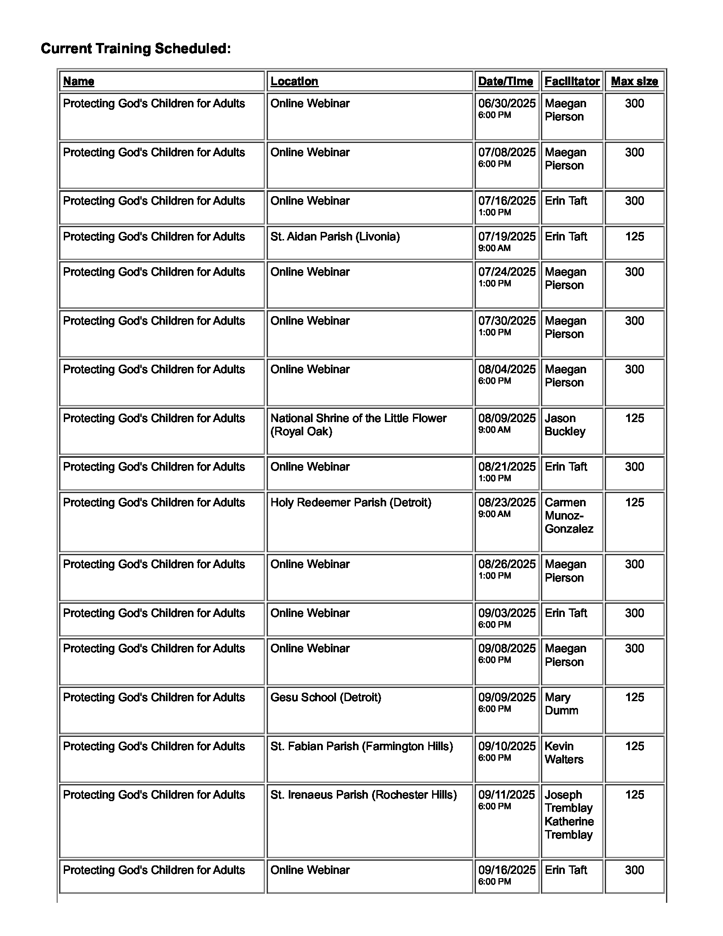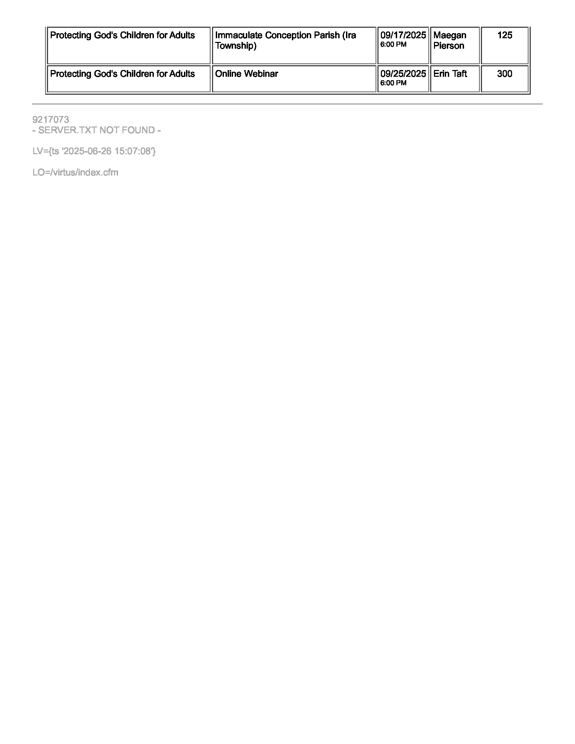
THANK YOU!
Thank you for taking the time to read about our program. Preschool is a very important part of your child’s education. We are excited about the prospect of working with you and your child for we know this is such a wonderful and special time in your child’s life. We are also very flexible here at Immaculate Conception, and we will do all in our power to see that your child is happy, secure and receives a well-balanced foundation so that they can grow and become all that they are meant to be. If at any time you should have questions or require additional information, please feel free to contact us through the main office at (586) 574-2480.

Sincerely,
The Staff at Immaculate Conception Preschool

Immaculate Conception Preschool
29500 Westbrook
Warren, Michigan 48092
586.574.2480 fax: 586.574.3497
www.icschoolswarren.org

2025-2026

Date: __________________________

I have read and understand the Immaculate Conception Preschool Parent-Student Handbook Plan, and I agree to abide by the rules and regulations stated therein.

Student’s Name (Please print): __________________________________

Room: _________

Lead teacher: ______________________________

Student’s Name (Please print): __________________________________

Room: _________

Lead teacher: ______________________________

Parents’/Guardians’ signatures: _________________________________

_________________________________

(Please return this form to your child/ren’s teacher.)

