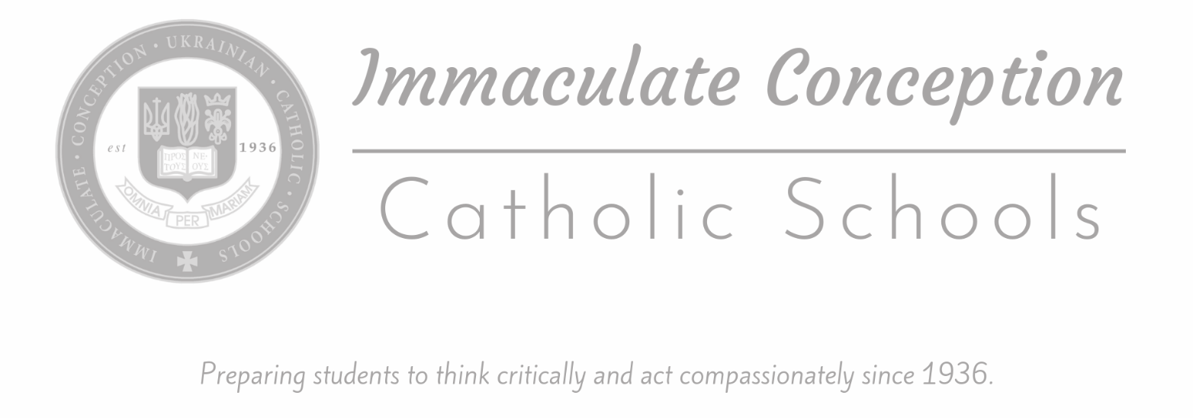

ELEMENTARY & ACADEMY

PARENT-STUDENT HANDBOOK
2025-2026

Rev. Daniel Schaicoski, OSBM, Pastor, Administrator
Ms. Mary Ann McFarland, Principal
Ms. Anita Colo, Assistant Principal

29500 Westbrook
Warren, Michigan 48092
Phone: 586-574-2480 Fax: 586-574-3497
www.icschoolswarren.org

Welcome to
Immaculate Conception Ukrainian Catholic Schools!

We invite all parents & students to become active participants in our school community, to experience a variety of opportunities for personal and academic growth, and to strengthen Catholic values.

Pastor/Administrator: Rev. Daniel Schaicoski, OSBM

Principal: Ms. Mary Ann McFarland

Assistant Principal: Ms. Anita Colo

Address 29500 Westbrook Ave, Warren, MI 48092 USA
Main Office 586.574.2480
Fax 586.574.3497
Website www.icschoolswarren.org
Facebook https://www.facebook.com/www.icschools2015
Main Office Email ic-office@icschoolswarren.org

The principal has the authority to interpret, clarify, and update any policy and/or terminology inadvertently omitted from this handbook.

Mission
It is our belief at Immaculate Conception that each child is a special gift from God, born with unique talents and abilities. It is our job as teachers to nurture these talents and abilities so that our students will grow and become all that God wants them to be and be prepared for the future.

It is also our desire to partner with the parents of our students in order to provide assistance, support, and insight into their child’s development. Our school promotes the development of self-confidence in each child within an atmosphere where physical, social, emotional, intellectual, and spiritual development will occur.

Vision
Immaculate Conception Catholic Schools envision our students achieving personal success and spiritual growth through active participation in the Catholic Faith and appreciation for their heritage.

Philosophy
We strive to instill in our students a love of God, respect for their heritage and a thirst for knowledge. We provide our students with the highest academic education and a thorough instruction in the Catholic faith. We offer the opportunity for a firm base in Ukrainian language, history and culture.

The school is under the special patronage of Our Lady the Blessed Virgin, in Her particular privilege of the Immaculate Conception.

Spiritual Direction
Immaculate Conception Catholic Schools is a private co-educational school directed by the religious order of Saint Basil the Great. The priests from both Immaculate Conception Ukrainian Catholic Church and St. Josaphat Ukrainian Catholic Church are available for both group and individual guidance for the students.

Administration and School Board
Ultimate authority for the school is vested in the pastors of the Immaculate Conception and the St. Josaphat Churches with the School Board serving in an advisory capacity. The principal is responsible for the review and formulation of policies relevant to the academic program and all aspects of the educational process in consultation with her staff and faculty. The principal reports to the pastor administrator.

Policies and Procedures
An educational institution requires an atmosphere where good order is maintained for effective learning to occur. The guidelines that follow in the parent-student handbook have been designed for this reason and require cooperation between principal, assistant principal, faculty, parents and the student body.

To view Health & Safety Guidance for Catholic Schools in the Archdiocese of Detroit, visit www.detroitcatholicschools.org.

Principal
The Principal is a committed educator who creates opportunities and an environment in which students, faculty and staff will be challenged to develop their spiritual, intellectual, social, emotional and physical gifts. The Principal is the organizer, communicator, coordinator and evaluator of the total school community, its activities and environment.

Assistant Principal
The Assistant Principal is the chief advisor to the principal, assuming full responsibility in the absence of the Principal in the general supervision of students and assignment of duties of the teaching and office staff.

Faculty
The Catholic school educator prepares students to be morally, socially and intellectually productive members of society.

ADMISSION
Immaculate Conception Ukrainian Catholic Elementary is a private Catholic school located in Warren, serving the Tri-County communities.

Admission is based on an interview, standardized test results and review of current grades. Students with disabilities will be evaluated for admission on an individual basis based upon their needs and the school’s ability to accommodate those needs. The final decision will be made by the pastor and the principal. Any willful neglect on the part of the parent or guardian to disclose a physical, educational or emotional handicap will result in the cancellation of the child’s registration and his/her immediate removal from school.

Placement tests may be given to determine proper eligibility for admission to a specific grade. New students will be accepted on probation for one quarter.

REGISTRATION REQUIREMENTS
When registering a new student, parents must present a birth certificate, a parent’s driver’s license or proof of residency, immunization records, physical with vision screening, and registration fee.
. Before May 30, 2025 Non-Refundable Application fee: 1 child - $200 fee; 2nd child - $200 fee; 3rd and more children - NO additional fee (cash or check payable to "IC Schools")
After May 30, 2025 Non-Refundable Application fee: 1 child - $400 fee; 2nd child - $400 fee; 3rd and more children - NO additional fee (cash or check payable to “IC Schools).

For new kindergarten enrollees, the child must be 5 years of age by September 1. All documents and records shall reflect the person’s God-given biological sex.

Registrations are accepted in the spring for enrollment the following year. Specific dates of registration are announced in school and church bulletins. Parents are informed of tuition rates and fees at time of registration.

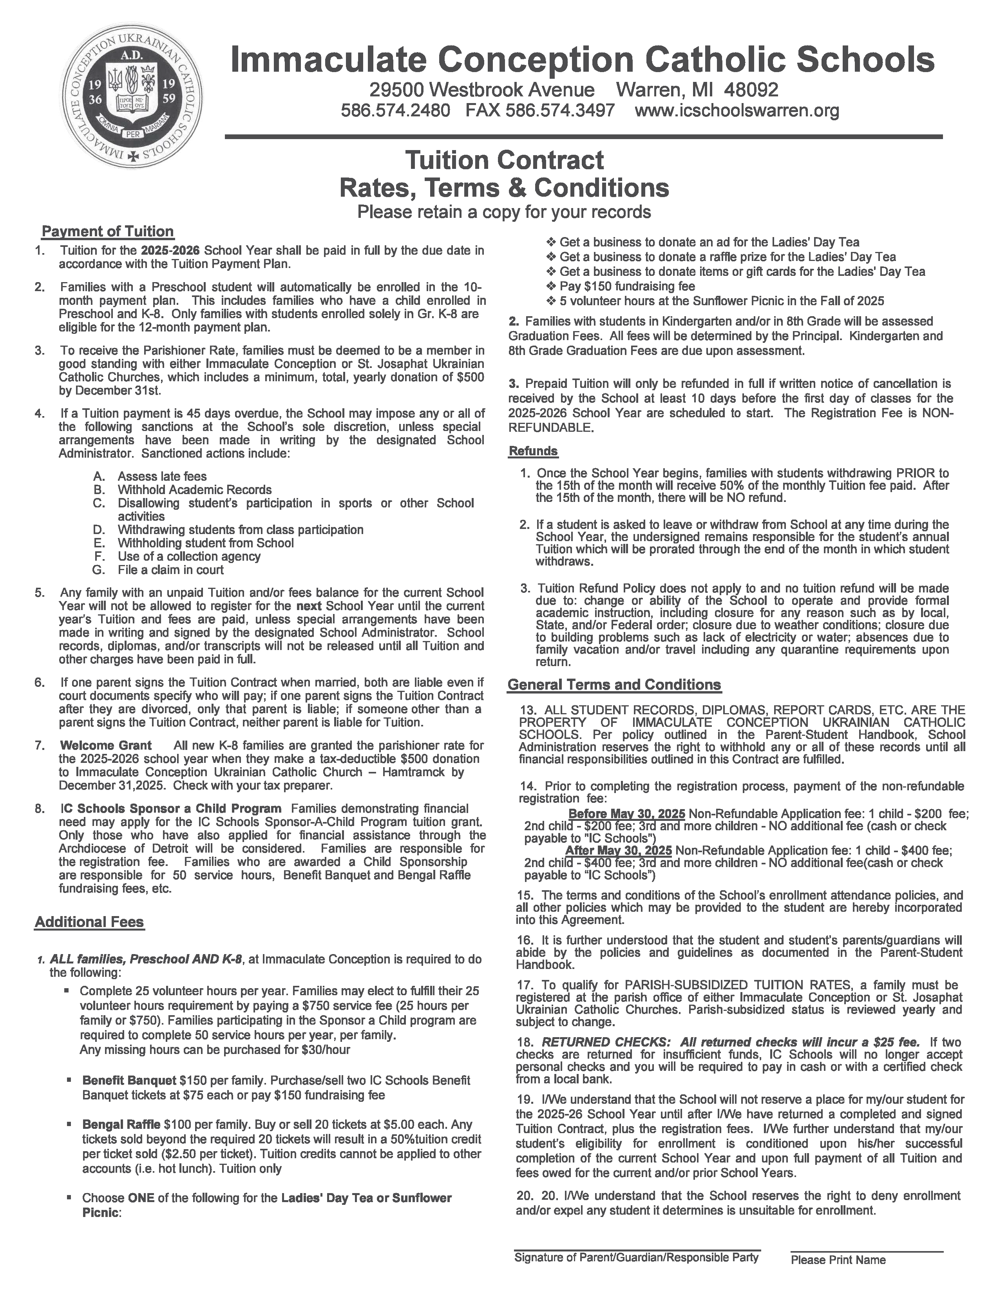
STUDENTS MAY NOT BE ENROLLED AT BOTH IC SCHOOLS AND ANOTHER SCHOOL. This includes, but is not limited to online, virtual, e-learning, distance learning, etc. programs at charter schools, private and/or public schools, academies, prep schools, etc.

Additional Fees:
Lost or Damaged Textbook/Workbook/Library Book: cost varies
Kindergarten and Eighth Grade Graduation Fee: Due by November 1.
Fundraising -- All Families, Preschool and K-8:
- Donate $150 or purchase two (2) Benefit Tickets ($75ea)
- Sell/purchase $100 Bengal Raffle Tickets

Immaculate Conception Ukrainian Catholic Schools, including the Preschool, does not offer tuition credit for sick days, holidays, unexpected closures, snow days, or vacation days. If a family must be absent for an extended period of time, they may choose to continue to pay tuition to hold the spot, or officially withdraw and reapply when ready if there are still vacancies in the class. Tuition credit for extended leave may be granted in rare circumstances at the discretion of the school administrator.

GENERAL SCHOOL HOURS
The school day begins at 7:40A and ends at 3:15P. School Office hours are 7:30A-3:30P. Students should arrive by 7:40A and will be admitted through their designated class entry/door. All students should leave the school promptly after dismissal at 3:15 through their designated class exit/door.
For the safety and security of our faculty and staff, NO STUDENTS OR PARENTS MAY ENTER THE SCHOOL BUILDING BEFORE 7:40A OR AFTER 3:15P WITHOUT AN APPOINTMENT. Students and parents will not be admitted to the building – including classrooms - to retrieve lost or forgotten items such as homework or textbooks. Parents and students may not “cut through” the building in order to meet teachers, other students, etc.

PARENTAL RESPONSIBILITY
Parents are asked to help their children develop a healthy and mature sense of responsibility by making sure that school and class rules are supported and followed.

Make certain your child comes to school in a uniform that is clean, well-maintained and of proper fit. The school is not responsible for lost articles.

Ensure that students arrive at school each day on time and prepared with all necessary supplies, materials, and assignments.

All students are expected to spend lunch recess outdoors. Please see that children are dressed properly for the daily weather conditions.

Parents are required to walk children to the outside classroom door for morning pick-up and for dismissal:
Preschool -- “Big Gym” doors
K-5 -- Outside classroom doors (off of playground)
Gr. 6 -- Hallway entrance door
Gr. 7-8 -- Outside classroom doors (off west parking lot)

DISMISSAL
For all grades Kindergarten-8: Regular dismissal is 3:15PM. Half day dismissal for all students is 12NOON.
Upon dismissal students become the responsibility of parents. Once dismissed, students should not re-enter the building. Families with special circumstances may make arrangements with the Main Office for group pick-up.

Please remember that a child who is picked up late can get anxious. Be respectful of faculty & staff and their time -- they may have other obligations past 3:15PM. Being on-time is a significant contributor to the job satisfaction of all teachers and the happiness of children.

An Aftercare program is provided as a courtesy to families who may need additional time to pick-up their children. The program runs 3:20P-5:00P, Monday thru Friday on FULL DAYS ONLY. No Aftercare will be available on half days or when school is not in session. Any students not picked-up by 3:20 are sent to Aftercare. A fee of $10.00 per child, per day is charged. Students must be signed out by a parent or authorized adult. A late fee of $5.00 per 5-minute increment will be charged after 5:00P. All times are determined by the school clock.

Any restrictions regarding the release of a student must be on file in the school office. For divorced or separated parents, a copy of the custody agreement/school release form must be on file in the office.
COMMUNICATION
IC utilizes several methods to communicate with parents and students. Parents and students are responsible for accepting invitations and/or signing up to the platforms listed below and reviewing information shared. If you do not receive messages via a platform, please contact the Main Office immediately. NOTE: Foreign email addresses ending in extensions such as .ru may not receive messages from our provider. We suggest families use an American-based email provider such as @yahoo.com, @gmail.com, @outlook.com, etc.

SPECIAL NOTE: If you wish to contact a teacher, please use your dedicated classroom platform (DOJO, Google Classroom) or email them directly. Remember, teachers may not be able to get back to you during instruction time. We thank you for your patience! Teachers will respond within two business days. For items that need immediate attention, please call the Main Office, 586.574.2480.

- Class DOJO (PS, K-4): Connects teachers and families through communication features, such as a feed for photos and videos from the school day, and messaging that can be translated into more than 35 languages. Each teacher has their own classroom code which they provide to parents. Accessible online and via the app. Do not use the paid version of Dojo.
- Email, ALL FAMILIES (PS, K-8): All IC Schools faculty and staff are assigned school email addresses for school use ending in @icschoolswarren.org. Please be sure to regularly check your email for messages from the Main Office, your child’s teachers, etc.
- Freckle (Gr. K-8): Freckle is an online learning platform that allows students to practice Math and English Language Arts at their own level. Freckle continuously adapts to each student's individual skills, so each student is getting the appropriate challenge, whether they're working at, above, or below grade level.
- Google Classroom (Gr. 5-8): For PARENTS & STUDENTS – THIS PROGRAM REQUIRES IC STUDENTS IN GR. 5-8 TO USE THEIR ASSIGNED @ICSCHOOLSWARREN.ORG EMAIL ADDRESS. A free web-based learning platform developed by Google, where teachers can communicate with students and families. Teachers share assignments, grade papers, etc. with students in a paperless way. Platform features vary by teacher. Please check with your child’s teacher to see how they plan to utilize this program.
- Jupiter Ed (Gr. K-8): Online gradebook used by IC Schools for students in Gr. K-8. Parents may review student assignments, grades, progress reports, and report cards.
- MailChimp, ALL FAMILIES (PS, K-8): Email program IC Schools uses to communicate with parents, particularly the weekly eNewsletter. Emails contain active links, graphics, PDFs, etc. Emails from MailChimp are labeled from “Immaculate Conception Catholic Schools”. Please add the email address to your contacts list. Be sure to check your junk/spam folder if you do not see it in your inbox.
- Remind App, ALL FAMILIES (PS, K-8): Communication platform that helps educators and moderators reach students and parents via text messages. Data rates and text message fees may apply. You may opt out at any time; however, you will no longer receive real-time updates about school closures, updates, etc. These communications are general reminders and sudden alerts (practice is cancelled, no school due to weather, special instructions for events, volunteer opportunities, etc.) that are specific to Immaculate Conception Ukrainian Catholic Schools families. Each family is assigned to a group according to the CHILD’s LAST NAME and parents should only join ONE GROUP per family. Moms and dads/guardians are both invited to join!
- Student Email (Gr. 5-8): All students in Gr. 5-8 are assigned an @icschoolswarren.org email address for SCHOOL USE ONLY (please see applicable policies within this handbook). This email is linked to a parent’s email address to allow for resetting the account/password.


The Protecting God's Children for Adults training is a research-based training program that educates adults on how to become better protectors of children from child sexual abuse. Participants will learn how to become safer adults who are a part of the solution to prevent, and respond to, child sexual abuse. The program includes the videos of A Time to Protect God's Children™ and A Plan to Protect God's Children™.
Throughout the training, participants will learn:
- The reality and context of child sexual abuse, as well as victim/survivor advocacy.
- How to identify problematic behavior that adults exhibit.
- How abuse affects survivors, their families, and their communities.
- The importance of maintaining healthy boundaries with children and youth.
- Empowering action items and five comprehensive research-based steps to prevent and effectively respond to child sexual abuse, including: identifying warning signs of adult behavior, screening and selecting employees and volunteers, using technology appropriately when interacting with minors, responding to disclosures from children and youth, communicating concerns about inappropriate behavior and reporting suspected abuse.
The Protecting God's Children program features an in-person, live webinar and individual online versions. In the in-person and live webinar versions, a licensed VIRTUS facilitator helps to guide participants through a robust discussion to emphasize key points. The online version features video content and comprehension questions. Available in English and Spanish, with subtitled versions in English (closed captioned), Korean, Vietnamese, French, Burmese, Polish and Portuguese.
Link to Register - Link to Register - https://www.virtusonline.org/virtus/

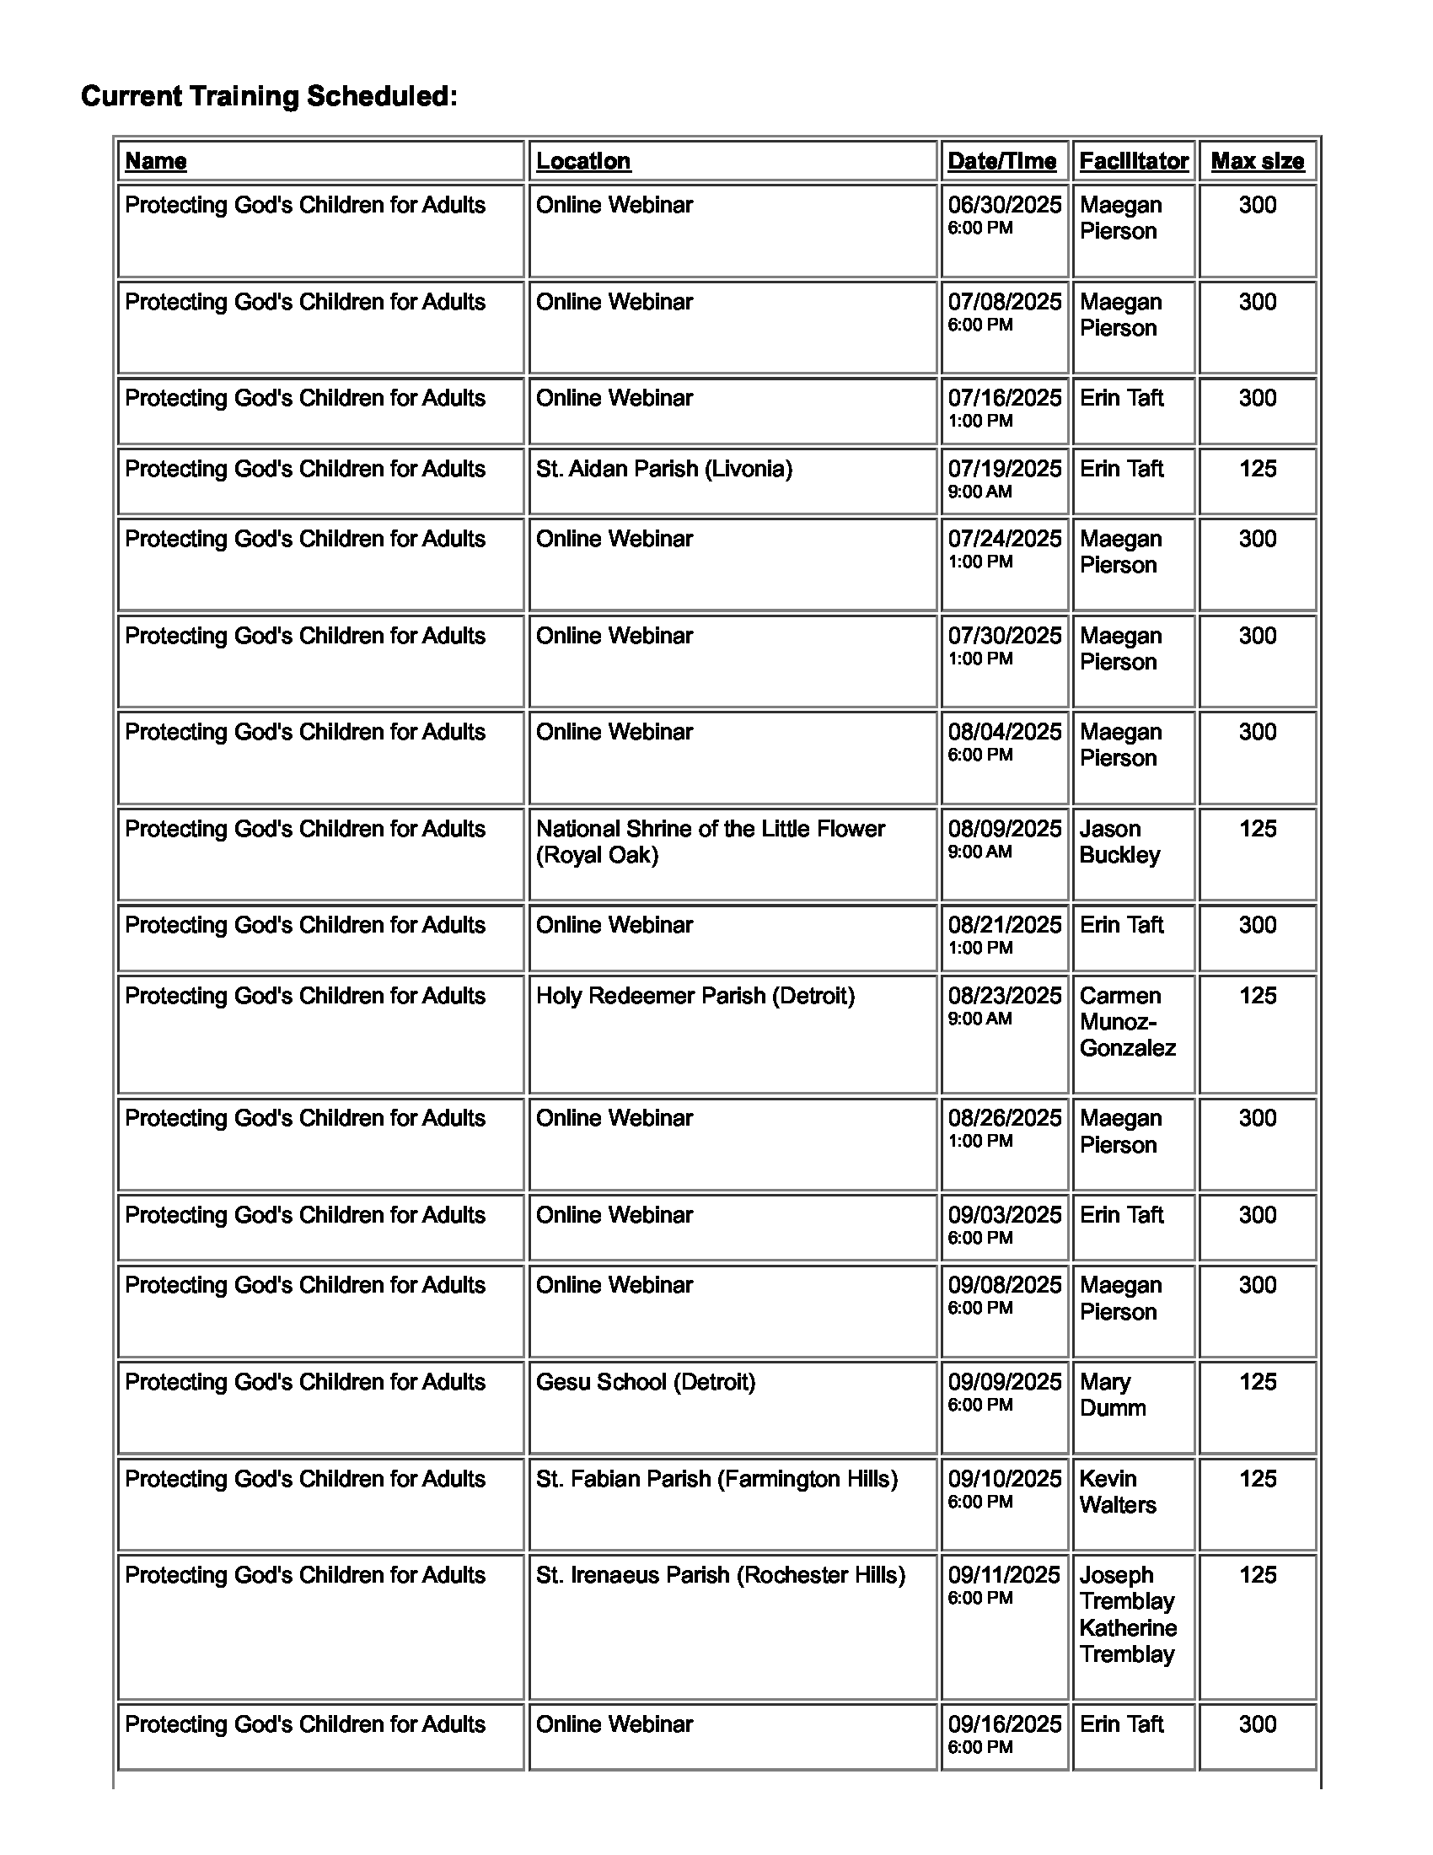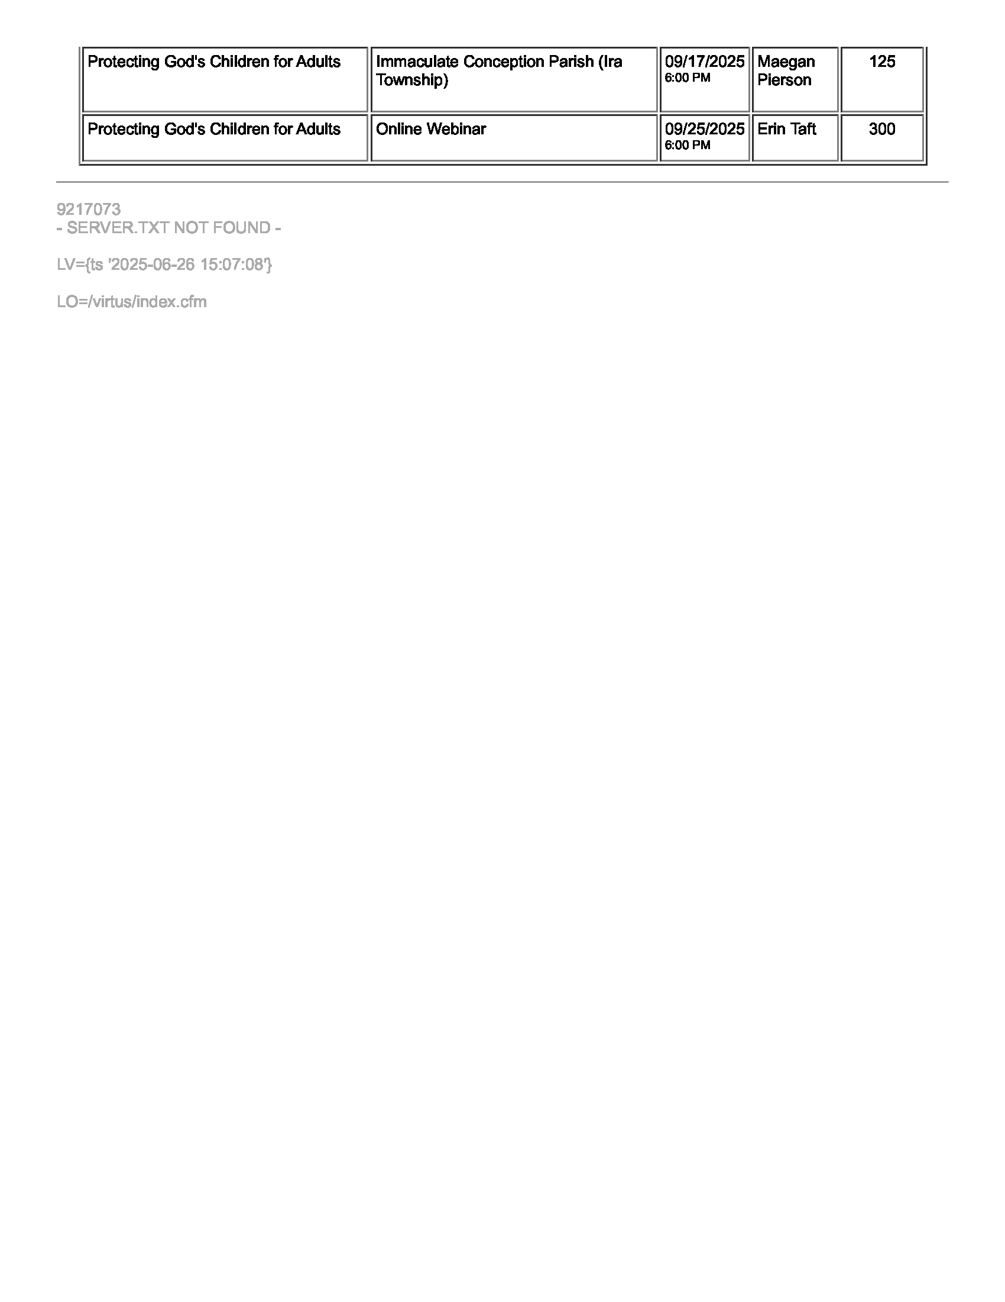
STUDENT CODE OF CONDUCT
At Immaculate Conception, every student has the right to study, learn, converse, and play in a community and environment that is safe, pleasant and conducive to academic and social maturation. The student who disrupts this atmosphere deprives others of the right to fair educational and social opportunity. Therefore, the following basic guidelines are stated here to aid students in their understanding of the school’s expectations of acceptable behavior.

A student at Immaculate Conception Schools
- adheres to all school rules;
- comes prepared to learn, participate, and succeed;
- reports punctually to class with necessary materials, assignments, and supplies;
- values courtesy, honesty, industry, and integrity by setting a good example for others;
- shows respect for faculty, staff, classmates, and self through work, voice, attitude, and action;
- respects the rights and property of others;
- makes every effort to maintain a clean and safe school environment.
- shows courtesy to all visitors;
- participates in school activities, shows proper sportsmanship during athletic contests and other functions
- takes pride in every facet of his/her school – its scholastic rating, appearance, name and reputation, and its Christian philosophy.

ATTENDANCE
All students, Preschool and Grades K-8, must be in the building by 7:40AM. Students arriving late must report to the Main Office for admittance. Attendance will be taken in the classroom at 7:45AM. The school day begins promptly at 7:45AM and ends with dismissal at 3:15PM. Students who are present for 4 hours or more are considered full day attendance. Students present for less than 4 hours are considered half (1/2) day absent.

Regular attendance and punctuality are important. However, if a student shows signs of illness before leaving for school, it is wise to keep him/her at home to avoid exposure for the other children and eliminate becoming ill in the classroom. Each day a student is absent, the parent must call the school office no later than 8:00AM to report the absence and request homework, otherwise, a student will receive their homework upon their return to class. DO NOT CONTACT THE TEACHER FIRST. The student is responsible for contacting each teacher to determine make-up work. After a contagious illness or 3 days of consecutive absence, clearance from a doctor is required for re-admittance to class.

Please Note: By law, schools are required to report cases of contagious illnesses to the Macomb County Health Department on a weekly basis. COVID-positive cases must be reported daily. Please leave a detailed message if your child has a contagious illness and may have been infectious during the school day. Written notification an illness has been reported will be sent home to inform all families of possible exposure to contagious diseases; for example: conjunctivitis (pink eye), lice, and chicken pox. Students will not be identified.

Excessive, unexcused absences or tardiness may affect grades or lead to retention. Students may be retained if they do not meet all academic criteria for promotion or have exceeded allowable absences for the school year. The maximum allowable days absent each semester are ten. More than ten absences per semester may result in a failing grade.

Absences of over 20 days may result in retention and be reported to the County Truancy Department. Students absent from school on the day of a scheduled event such as: field trips, sporting events, or extracurricular activities, may not participate in the event.

Extended vacations taken during the school year, other than scheduled school vacation time, are strongly discouraged. Please remember that students are at a disadvantage by missing the interaction of class lessons and assigned work. No assignments will be given in advance of a preplanned or unreported absence. Textbooks are not to be taken on vacation. Work will be made up upon return and homework is posted daily on the class website.

To be excused from class early, a student must present a note from a parent to the teacher OR the parent may email/message via class platform by 8:00AM. Before a child can be excused from class the parent or guardian must report to the school office to sign the student out. A student who becomes ill while in school will be sent to the school office. The office will contact a parent. Student use of cell phones for this purpose is strictly prohibited. Leaving school premises without permission warrants detention.

If it should be necessary to close the school because of weather conditions, parents will be notified by TEXT message through the Remind App, an announcement will be made over the local radio and TV stations, and posted on the school website and Facebook pages.

LATE ARRIVAL
Late arrival is disruptive to the learning process; therefore, students are expected to be on time for class, in full uniform with supplies and books.

CURRICULUM – Students in Grades 1-8 must choose Ukrainian, ESL Enrichment, or Writing Workshop at the beginning of the year and changes can’t be made mid way
Kindergarten Core Subjects
- Religion
- Reading
- Ukrainian
- Phonics
- Math
- Science
- Social Studies

Grades 1-3 Core Subjects
- Religion
- Ukrainian/Writing Workshop/ELE
- Math
- Science
- Social Studies
- Reading
- English: Spelling, Phonics (Gr. 1 & 2), Handwriting

Grades 4-6 Core Subjects
- Religion
- Ukrainian/Writing Workshop/ELE
- Language Arts: Literature, Writing, Grammar, Vocabulary, Spelling
- Math
- Advanced Math
- Science
- US History / Geography

Specialties, Gr. K-8
- Computers
- Physical Education
- Music
- Choir
- Spanish
- Art
- Weekly Liturgy
- Media

STAR Standardized testing will be given 3 times a year, as mandated by the Archdiocese.

HOMEWORK
Homework consists of any assignment as directed by the teacher. For every day a student has an excused absence the same number of days will be provided to make up the missed work. Daily assignments and communications will be posted on the student-parent portals: Dojo (PS-Gr. 4) and Google Classroom (Gr. 5-8). Each student at Immaculate Conception Schools is expected to do homework.

SEMESTER TESTING
Academy students in Gr. 6, 7, and 8 will complete a Science Fair/research project at the end of Semester I and a cumulative assessment at the end of Semester II.

REPORT CARDS AND CONFERENCES
Report cards are issued four times a year. Interim progress reports will also be issued in the middle of each marking period. Parents in Gr. K-8 will be able to access Progress Reports and Report Cards online through the JupiterEd portal.

Conferences are scheduled twice a year, according to the school calendar. Parents are encouraged to make an appointment with the teacher any time the need arises. Additional conferences may occur per teacher request as well.

Communication by parents concerning curriculum, classroom routine, class work, and child’s progress must first be directed to the teacher.

If a situation warrants further clarification, the principal should be contacted and a conference between all parties will be arranged. Appointments are necessary.

ALL STUDENT RECORDS, DIPLOMAS, REPORT CARDS, ETC. ARE THE PROPERTY OF IMMACULATE CONCEPTION UKRAINIAN CATHOLIC SCHOOLS. School Administration reserves the right to withhold any or all of these records until all financial responsibilities outlined in the Tuition Contract are fulfilled. This includes forwarding records to another school to facilitate transferring or graduating.

ACADEMIC/CORE SUBJECT GRADES
Grading scales are set by the Archdiocese of Detroit.
Grades 3 - 8
A = 93 - 100% Excellent
B = 83 - 92% Very Good
C = 72 - 82% Satisfactory
D = 60 - 71% Poor
F = 59% and below Failure
Grades K – 2
1 = 100% - 83%, Proficient
2 = 82% - 72%, Developing
3 = 71% - 0%, Needs Support

*NG = NO GRADE GIVEN at this time.

Students may be retained if they fail to meet all academic criteria for 3 core subjects or have exceeded absences for the school year (see attendance policy).

"Specials" Grading Scale
These classes include Art, Choir, Computers, Music, Spanish, and Physical Education.
Student work demonstrates...
1 = Consistent and advanced understanding of grade level standards and objectives.
2 = Consistent understanding of grade level standards and objectives.
3 = Partial understanding of grade level standards and objectives.
4 = Minimal understanding of grade level

CITIZENSHIP / CONDUCT
1 = Good – Always courteous, adheres to rules
2 = Fair – Courteous, adheres to rules most of the time
3 = Poor – Needs improvement
4 = Unacceptable

ACADEMIC PROBATION
Academic Probation is a serious matter. The administration reserves the right to warn or place a student on Academic Probation, especially in circumstances where a student fails a class in a given marking period. Students and their parents are expected to comply with all stipulations made in the letter shared with parents and any additional requirements noted as a result of academic probation.

Written probation letters are provided as a warning that skills/scores are not at grade-level and IC Schools Administration may further advise all or part of the following:
- Students are placed in a grade level for a trial period, at the end of which, performance will be reviewed and the student may be moved to a more appropriate grade level, including a lower grade.
- Students did not demonstrate mastery of grade-level skills and should remain at current grade level rather than being promoted to allow for further development of skills.
- IC Schools Administration recommends the student remains at current grade level for another year.

A student whose skills are not at grade level and/or is failing will be evaluated and may be placed on academic probation. If a student is placed on probation, parents will be notified in writing. A meeting with the child’s teacher/s and/or IC Administration may be required. An individualized improvement plan may be developed to establish guidelines to bring the student’s overall performance to grade level. The plan may include recommendations such as, but not be limited to: after school academic support, directed study, tutoring, additional English language learning resources, or parent provided independent support. The parents are expected to monitor the student’s progress through JupiterEd. The plan may be amended as needed while the student is on probation. Students who fail to rise to achieve academic progress may have their probation extended.

HONOR ROLL
The IC Academy Honor Roll is based on scholastic achievement and is computed at the end of each semester. Students with a scholastic average GPA of 3.1 to 3.5 in core subjects and an overall conduct grade of 2.0 in core subjects or better are entitled to be placed on the Honor Roll.

A student who maintains a scholastic average of 3.6 to 4.0 in core subjects with an overall conduct grade of 2.0 in core subjects will have earned High Honors. GPA in core subjects will be rounded to the second decimal.

Participation in athletics has no bearing on Honor Roll status.

NATIONAL JUNIOR HONOR SOCIETY
Selection to the NJHS is a privilege, not a right. Students who have earned a 3.3 GPA or higher in core subjects and no less than a 1.8 for a citizenship grade in core subjects are eligible for consideration for membership on the basis of community service (8 hrs. per year in addition to the 15 hours required for Academy students), leadership, and character in the Taras Shevchenko Chapter of the NJHS.

Participation in athletics has no bearing on National Junior Honor Society status.

COMMUNITY SERVICE
A student is required to provide a minimum of fifteen (15) hours of documented community service during the time enrolled at the 6th-8th Grade Academy. The student may choose the charity or organization, but it is preferred that most service hours be connected with a church or school. Some suggestions include the following: Church acolyte or lector, hospital or senior volunteer. Service for personal gain, class requirement, or performed during detention is excluded from credit. The student is responsible for obtaining the proper documentation and signature on the required form and then submitting it to their Gr. 6, 7, or 8 homeroom teacher.

EDUCATIONAL FIELD TRIPS
Field trips of significant value are permitted and encouraged. Field trips supplement the instruction program by utilizing the educational resources of the community. In keeping with the class’ instructional objectives, teachers in K-8 plan the place of the field trips. Participation in field trips is a privilege and can be denied to students who fail to meet behavior requirements.

As field trips are an extension and requirement of particular classes, all students are expected to attend. If a student is absent on the day of the field trip, trip fees will not be refunded as the fees are based on a specific number of students for class participation. Students who do not attend a field trip and remain at home with the parent will be marked absent for the day.

Parents will be informed through the use of a permission slip that must be signed and presented to the supervising teacher prior to the trip. All school rules of proper conduct apply to school-sponsored activities. The school dress code will be in effect for field trips, unless specifically noted.

When possible, students will be transported by bus. Teachers, students, and when necessary, chaperones may use the bus for local field trips. When transported by a private car, drivers must present a copy of a valid driver’s license, proof of Personal Injury Protection coverage, and an authorization for a Motor Vehicle Report. Drivers must be at least twenty-five (25) years of age unless the person is a parent of a child participating in the field trip. Drivers must be VIRTUS trained. Drivers are NOT to take or make any unscheduled stops (i.e. for food, drink, etc.). Students must return to school after the field trip. Parents chaperoning may not take their child home from the field trip location or pick them up from the field trip.
NO STUDENTS ARE ALLOWED TO LEAVE SCHOOL GROUNDS WITHOUT A SIGNED PERMISSION SLIP ON FILE.

Siblings may not be taken on field trips so that chaperones may fulfill their duties. Student guests are not permitted.

Extracurricular Events
Immaculate Conception Schools sponsors a variety of extracurricular events for its students throughout the year. Students wishing to invite guests from other schools must obtain permission in advance from the Administration. Guests must be in grade school (K-8) or out of grade school less than 1 year. If permission is granted, a Guest Permission Slip will be provided. Both the hosting family AND the guest family must complete and sign it. Completed forms must be returned to Immaculate Conception Schools’ Main Office prior to the event. Guest students agree to abide by Immaculate Conception Schools rules of conduct. The host family is solely responsible for the guest student.

Students may not participate in Extracurricular Events if they are absent the day of the event.

BIRTHDAY CELEBRATIONS
Due to limited instructional time and allergies, birthday celebrations are limited to the classroom only with individually pre packaged treats and are at the discretion of the homeroom teacher. As a special privilege for the birthday student, they may dress down on their birthday. If your birthday falls on a Friday – you may dress down Monday or Thursday due to Divine Liturgy (see dress down guidelines).

LOCKERS
Academy students will be assigned a locker. Students will be responsible for maintaining the locker in good working order. The school administration reserves the right to inspect the student’s locker.

UNIFORM
All students at Immaculate Conception Elementary School and Academy should dress neatly and in accordance with the school rules governing proper attire. Blouses/shirts are to be completely tucked into waistbands. Students not in accordance with the dress code will receive a violation, which will be sent home to be signed by the parent. Repeated violations will result in demerits and detention.

Preschool & Kindergarten
- Solid navy-blue shorts or sweatpants. No denim, stretch pants or leggings are allowed.
- Solid gray short or long-sleeved T-shirt with the IC school logo (2024/25 version or new version from Emilia’s)
- Sweaters – Solid navy-blue or white sweater or sweater vests may be worn.
- Sweatshirts/hoodies- Navy-blue (2024/25 version or new gray version from Emilia’s) with school logo, official spirit wear sweatshirts/hoodies, OR solid navy-blue sweatshirts are allowed in cold weather.
- Shoes - Solid-colored dress shoes OR solid colored tennis shoes are worn with school uniforms. Any logo (Ex. Nike ‘swoosh’, Adidas stripes, Under Armour, etc. but not limited to, needs to be the same color as the shoe. Black shoes with a black Nike ‘swoosh’ are acceptable. Black Nike shoes with a white ‘swoosh’ are NOT acceptable. Acceptable shoe colors are gray, brown, white, navy-blue, or black. Velcro or slip-on, no ties/shoelaces. All shoes must have a non-marking sole. Shoes must not light up or make sounds. Higher heels, platforms, mules, cloth, backless shoes or sandals are not allowed. Boots are not to be worn in class. If a student wears them to school, they must change into school shoes for classes; during cold weather, they may wear boots during outdoor recess.
- ATHLETIC SHOES/CLEATS – NO athletic shoes/cleats may be worn on campus during school hours. This includes recess and gym class.
- Fake nails, bright-colored nail polish/designs, and make-up are not allowed.
- Jewelry is restricted to one small pair of earrings or simple necklace. NO WATCHES.
- Girls’ hair must be neat and well groomed. Hair must not be a distraction. Therefore, bleached or frosted hair, bizarre hair colors, or hairstyles (such as “spiked hair”, “Mohawks,” or shaved heads) are not permitted.
- Boys’ Hair - Hair must be neat, clean, trimmed, and well-groomed. Hair past the collar must be pulled back into a bun.

Girls Uniform, Grades 1-8
- Girls in Grades 1 - 5 are to wear plaid jumper uniforms (2024/25 version or new version from Connies), plaid skorts (2024/25 version) or new plaid skirt (from Connie’s), plain white blouses or school polos (2024/2025 version or new version from Emilia’s) and only navy-blue or white tights, leggings, or knee socks. All blouses and polos must be tucked into the waistband. Girls may choose to wear “modesty shorts” (from Connie’s)/legging shorts under their skirts. Jumpers/skirts must not be more than three inches above the knee.
- Girls in Grades 6 - 8 are to wear gray pleated skirts (2024/2025 version) or new version of blue plaid skirts (from Connie’s) with plain white blouses or school polos (2024/25 version or new version from Emilia’s) tucked into the waistband, and black, gray, white or navy-blue knee socks, leggings, or tights. Girls may choose to wear “modesty shorts” (from Connie’s)/legging shorts under their skirts. Skirts must not be more than three inches above the knee.

- Slacks – Solid navy-blue uniform slacks may also be worn with school polos. No denim, stretch pants or leggings are allowed.
- Sweaters – Solid navy-blue or white sweater or sweater vests may be worn.
- Sweatshirts/hoodies- Navy-blue (2024/2025 version or new gray version from Emilia’s) with school logo, official spirit wear sweatshirts/hoodies, OR solid navy- blue sweatshirts are allowed in cold weather.
- Shoes - Solid-colored dress shoes OR solid-colored colored tennis shoes are worn with school uniforms. Any logo (Ex. Nike ‘swoosh’, Adidas stripes, Under Armour, etc. but not limited to, needs to be the same color as the shoe. Black shoes with a black Nike ‘swoosh’ are acceptable. Black Nike shoes with a white ‘swoosh’ are NOT acceptable. Acceptable shoe colors are gray, brown, white, navy-blue, or black. Velcro, slip-on, ties/shoe laces are permitted. All shoes must have a non-marking sole. Shoes must not light up or make sounds. Higher heels, platforms, mules, cloth, backless shoes or sandals are not allowed. Boots are not to be worn in class. If a student wears them to school, they must change into school shoes for classes; during cold weather, they may wear boots during outdoor recess.
- ATHLETIC SHOES/CLEATS – NO athletic shoes/cleats may be worn on campus during school hours. This includes recess and gym class.
- Fake nails, bright-colored nail polish/designs, and make-up are not allowed.
- Jewelry is restricted to one small pair of earrings, a watch and religious medal or cross on a small chain.
- Hair must be neat and well groomed.

Boys Uniform, Grades 1-8
Boys in grades 1 - 8 are to wear solid navy-blue uniform dress pants (no cargo pants or denim pants are allowed) with a white dress shirt or school polo (2024/2025 version or new version from Emilia’s). All shirts and polos must be tucked into the waistband. Only plain white undershirts are allowed with uniforms and must not be visible.

- Sweaters - Solid navy-blue/white sweaters or sweater vests may be worn.
- Sweatshirts/hoodies- Navy-blue (2024/25 version or new gray version from Emilia’s) with school logo, official spirit wear sweatshirts/hoodies, OR solid navy-blue sweatshirts are allowed in cold weather.
- Shoes - Solid-colored dress shoes OR solid-colored colored tennis shoes are worn with school uniforms. Any logo (Ex. Nike ‘swoosh’, Adidas stripes, Under Armour, etc. but not limited to, needs to be the same color as the shoe. Black shoes with a black Nike ‘swoosh’ are acceptable. Black Nike shoes with a white ‘swoosh’ are NOT acceptable. Acceptable shoe colors are gray, brown, white, navy-blue, or black. Velcro or slip-on, no ties/shoe laces are permitted. All shoes must have a non-marking sole. Shoes must not light up or make sounds. Higher heels, platforms, mules, cloth, backless shoes or sandals are not allowed. Boots are not to be worn in class. If a student wears them to school, they must change into school shoes for classes; during cold weather, they may wear boots during outdoor recess.
- ATHLETIC SHOES/CLEATS – NO athletic shoes/cleats may be worn on campus during school hours. This includes recess and gym class.
- Jewelry is restricted to a watch and religious medal or cross on a small chain.
- Hair - Hair must be neat, clean, trimmed, and well-groomed. Hair past the collar must be pulled back into a bun.

Spring/Summer Uniform
When temperatures reach 80F or higher, students in grades 1-8 may wear uniform shorts. Solid navy-blue uniform shorts (should be no more than three inches above the knee) may be worn with school polos (2024/25 version or new version from Emilia’s) and school shoes. Kindergarten and Preschool students may wear gym uniforms, navy-blue jersey knit shorts.

NO SHORTS MAY BE WORN FRIDAYS DUE TO DIVINE LITURGY.

NO STRETCH PANTS/SHORTS, BIKE SHORTS, SPANDEX SHORTS/PANTS OR LEGGINGS.

NO ATHLETIC SHOES/CLEATS may be worn on campus during school hours. This includes recess and gym class.

Gym Uniform
Students in Grades 4-8 are required to wear the school gym uniform. Gym gray T-shirts (short or long sleeved) can be purchased from Emilia’s Custom Creations. The link was above in the introduction of this letter. Students will wear gym uniforms to school on gym day instead of the regular IC dress uniform. Students will not be allowed to change into gym clothes during school. Gym attire is required:

- Solid gray T-shirt with IC logo (2024/2025 version or Emilia’s Custom Creations)
- Solid navy-blue jersey knit, or mesh gym shorts should be no more than three inches above the knee.
- Solid navy-blue sweatpants are also acceptable. NO DEMIN, STRETCH, LEGGING-TYPE SWEATPANTS. NO LOGOS or WRITING.
- Non-marking UNIFORM tennis shoes mentioned above (solid gray, brown, navy-blue, black, white)
- ATHLETIC SHOES/CLEATS – NO athletic shoes/cleats may be worn on campus during school hours. This includes recess and gym class.

Uniform Code Violations
All students are expected to be in accord with the uniform code on a daily basis. Repeated violations will result in the following:

UNIFORM VIOLATIONS FOR KINDERGARTEN-Gr. 2
FIRST VIOLATION: Teacher informs parent of violation and of the consequences following a second occurrence

SECOND VIOLATION: Parents will be required to bring a change of clothing to school or the student will be lent articles (when available) from the IC PTO Used Uniform Sale. Borrowed items must be washed and returned the next day. Parents may choose to purchase the items instead.

UNIFORM VIOLATIONS FOR Gr. 3-8
FIRST VIOLATION: Teacher informs student of violation and of the consequences following a second occurrence

SECOND VIOLATION: Parents will be required to bring a change of clothing to school or the student will be lent articles (when available) from the IC PTO Used Uniform Sale. Borrowed items must be washed and returned the next day. Parents may choose to purchase the items instead.

Dress-Down Days FOR GR. K-8
Students will be allowed to wear appropriate alternate apparel. Directions for theme days will be sent home. Regardless of the theme for the dress-down day, students are not allowed to wear: halter tops, shirts with derogatory words or pictures, stretch pants, leggings, or crop tops. No bare mid-driffs, see-through tops, or pants/shorts in disrepair (holes, rips, etc.). ABSOLUTELY NO STRETCH PANTS/SHORTS, BIKE SHORTS, SPANDEX SHORTS/PANTS OR LEGGINGS. NO athletic shoes/cleats may be worn on campus during school hours. This includes recess and gym class.

NUT PASSES (No Uniform Today)
Students who receive a NUT Pass may dress down following the dress down policy. These passes must be used within two school days from the date received. They must be visible on the clothing. Passes may not be used on Fridays due to Divine Liturgy.

DRESS-DOWN DAY DRESS CODE VIOLATIONS
FIRST VIOLATION: Teacher informs parent of violation and of the consequences following a second occurrence

SECOND VIOLATION: Parents will be required to bring a change of clothing to school or the student will be lent articles (when available) from the IC PTO Used Uniform Sale. Borrowed items must be washed and returned the next day. Parents may choose to purchase the items instead. Dress-down privileges will be suspended for the remainder of the quarter.

Spirit Days
Every Wednesday, students may wear IC Bengalware shirts/hoodies/socks with their uniform skirts/skorts/jumpers or pants in place of their IC uniform gray shirts or IC polos.

STUDENT HEALTH & WELLBEING
MEDICAL NEEDS/DISPENSATION OF MEDICATION
- It is the responsibility of parents and/or guardians to inform the principal and appropriate teachers if a student is subject to any medical need that requires regular or periodic attention while at school.
- No member of the faculty or staff may distribute any form of medication, including aspirin, unless a “Release for Dispensing Medication” form, signed by a physician, is on file in the school office. Medication will be dispensed in the presence of another adult.
- In accordance with Public Act 10 of 2000, the school will allow students to possess and use metered dose asthma inhaler or epinephrine auto-injector (epi-pen) or epinephrine inhaler provided written approval to possess and use these devices from the physician and parents is received by the principal, along with a written emergency care plan. The principal will notify the student’s classroom teachers.
- A “Medical Treatment Release” form must be updated annually and be on file for each student at the beginning of the school year.

WELLNESS POLICY
Immaculate Conception Schools are committed to providing a school environment that promotes and protects our children's health, well-being, and ability to learn by supporting healthy and physical activity. Therefore, it is the policy of the school that all students in grades Pre K - 8 will have opportunities, support, and encouragement to be physically active on a regular basis. Each student attends a Physical Education class at least once a week. In addition:

- Parents are encouraged to provide a healthy breakfast each day, and if packing a lunch for their children, to provide healthy choices from each food group.
- The School Hot Lunch program served meets the nutrition recommendations of the U.S. Dietary Guidelines of Americans. Every effort shall be made to provide nutritious and appealing foods and beverages, such as fruits, vegetables, low-fat dairy foods, and whole grain products.
- Cafeteria workers are trained in foodservice handling and abide by the local health code policies.
- Teachers promote hand washing before lunch periods or snack breaks.
- The school provides a clean, safe, and pleasant setting and adequate time for students to eat.
- The school schedules appropriate lunch periods followed by outdoor recess whenever possible. Playgrounds are monitored by adults and checked for safety.
- The school will accommodate the needs of children with food and drug allergies.
- The school accommodates the tooth-brushing regimens of students with special oral health needs such as orthodontics or high tooth decay risks.
- Parents sending in snacks or special treats are encouraged to provide healthy choices such as fruits or vegetables.

LUNCH POLICY
Immaculate Conception Schools provides families with the option of purchasing hot lunch from the school. The program is open to students in Preschool and Grades K-8 on full days only. There is NO lunch service on half days. In order to allow the kitchen to plan ahead and have meals on hand for all students who wish to participate in the program during the order period, we must ask families to abide by the policy below.
- HOT LUNCH ORDERS MUST BE TURNED IN WITH PAYMENT BY THE DUE DATE NOTED ON THE ORDER FORM. NO LATE ORDERS WILL BE ACCEPTED. NO ORDERS WITHOUT PAYMENT WILL BE ACCEPTED. Students who are absent the day orders are due must turn in their order form with payment on the day they return to school from illness. No late orders will be accepted from students absent due to vacation. Students whose lunch orders are late/unpaid/not accepted MUST bring a lunch from home the entire month.
- Payment must be made in exact change. No change will be provided. Any additional funds will be applied to the student’s account and rolled over to the next month. If you have account questions, please contact the school kitchen directly.
- Lunch may not be ordered daily. Only pre-paid lunches will be served.
- Lunches brought/delivered to school must arrive at least 15 minutes prior to the student’s designated lunch period:
- Gr. 6, 7, 8 Academy – 10:50AM – 11:35PM
- Preschool – 11:15AM – 12:20PM
- Kindergarten, Gr. 1, 2 – 11:35AM – 12:20PM
- Gr. 3, 4, 5 – 12:20PM – 1:05PM

PHYSICAL ACTIVITY
Immaculate Conception Schools shall provide a daily, supervised recess period to all students. Students shall be provided opportunities for physical activities through a range of school programs.

The CYO at the school shows our students the importance of sports, sportsmanship, and camaraderie. Students must comply with CYO guidelines by maintaining grades and school attendance, thereby encouraging a physically and mentally healthy child.

The Physical Education program exposes the students to a variety of activities. Students are taught the benefits of living a healthy active lifestyle and learn that the heart muscle is the most important muscle of all. Along with the teaching of game and skill concepts, students learn cooperation and sportsmanship through team building lessons. The students are also taught proper character traits that will stay with them well into adulthood.

At the K - 2 grade level, students are taught basic movement patterns along with the manipulation of various sports equipment. The skills they learn at this level will prepare them for the later grades when team and individual games are taught.

At the 3 - 8 grade level, there are a wide variety of sports activities taught. The purpose is to find an activity for everyone to achieve success and to enjoy. Upon the completion of 8th grade, every student should have a broad knowledge of numerous sports and the rules they encompass.

ATHLETICS
Immaculate Conception Schools participate in the Catholic Youth Organization (CYO). Athletes must maintain a minimum overall grade of C and a 2 or better in overall citizenship. Students absent on the day of a game may not participate in the game. A current sports physical must be on file, dated no earlier than April 15 of the start of the current school year.

Athletics clubs/teams are required to take their own team photos featuring ALL members for use by IC Schools including the school yearbook. Photos must be forwarded to the Main Office by the designated date.

CONCUSSION POLICY
The school office must be notified if a student is diagnosed with a Concussion. A doctor’s note must accompany any student returning to school after a diagnosis.

SCHOOL SAFETY
CRISIS PLAN
In the event of a major life-threatening emergency, school will be “locked-down” or students moved to another location where students may be collected. All students and parents will be advised of this location in the event of an emergency. Parents should also listen to their local radio stations and televisions in the event of such a crisis, as they will also be apprised of the situation. Communication will be through text message via the Remind APP and phone calls.

Fire / Tornado Plan
Necessary exits are posted in each classroom. In the event of a blocked doorway, alternate exits are given. Students have practice drills during the school year. Safe rooms are assigned to each class for tornado drills.

School Closings
School closings due to inclement weather conditions will be announced by text message on the Remind App, school website, and Facebook page as well as local radio and television stations. If Immaculate Conception Schools is closed due to weather conditions, the Preschool will also be closed. The school will be listed as Immaculate Conception Catholic – Warren. Please refrain from calling the school office, faculty/staff, church rectory, or clergy to verify closings.

DISCIPLINE POLICY
Student actions and attitudes must reflect the standards of a Christian community. Parents and the school staff share the responsibility to maintain these standards in each student by providing a good example and encouraging behavior that recognizes the rights of all others.

A high standard of conduct is expected and will be maintained at Immaculate Conception Schools. The students are expected to behave in a manner that enhances the learning environment.

If a student’s actions and/or behavior are deemed unsafe to the student, other students or the community, then based on those actions/behavior, the student may be asked to temporarily pause school attendance. Whether the student’s actions or behavior or deemed “unsafe” is at the sole discretion of the principal, vice principal or representative, after meeting with child and/or parents or guardian. In order to return to school, the parent and/or guardian shall provide a written evaluation report or any other evidence or proof, from a qualified medical professional, relative to the student’s action or behavior. Any actions or behaviors may be reported by the school’s principal, vice principal or representative, to the police department. For example, incidents involving a student’s mental health would require a mental health specialist evaluation, such as a psychiatrist. A pediatrician’s evaluation would not meet the standard as they are not a mental health specialist.

- Any altercation not witnessed by a representative of IC Schools and/or other adult will warrant both parties involved receiving appropriate consequences.
- Any inappropriate student behaviors, as defined by IC Schools Administration, sanctioned by a parent/guardian will warrant appropriate consequences.
- Behavioral consequences will be tracked throughout the full school year, not by marking period.

The following actions are prohibited and warrant a demerit, detention, or suspension:
- Consuming gum ($5.00 fine), candy, snacks, drinks in the classroom or school building without permission.
- Bringing in any unauthorized electronic devices.
- Failing to maintain the clean and neat environment of the school.
- Violating the school dress code.
- Violation of discipline and classroom order.
- Possession and/or distribution of any medication.
- Cheating; including passing other student’s assignments as your own, copying during tests, plagiarism, in any form, including, but not limited to, the use of platforms such as ChatGPT and AI. Grades on tests and assignments that are compromised will receive a 59%.
- Use of objectionable language, written or spoken and the use of obscene gestures.
- Falsifying parental signatures on papers.
- Visible or audible cell phones during school hours will be confiscated and returned only to a parent.
- Students’ privilege to bring a phone to school can be denied by IC Administration at any time.

The following will also warrant restitution, suspension, or expulsion:
- Possession of potentially dangerous materials or drugs on school property.
- Invading the privacy of teachers’ desks and/or files and those of other students.
- Hostility – such as fighting, insolence, harassment, etc.
- Malicious destruction, vandalism, or stealing.
- Possession, concealing or transferring a weapon and/or destructive device.
- Students may be disciplined, up to and including expulsion, for conduct inside or outside school that is deemed by the principal and pastor as detrimental to the school community.
- The administration of the discipline policy is at the discretion of the principal.

INTERVENTION
DISCIPLINE PROCESS
Infractions of school or classroom rules will be dealt with in the following manner, depending upon the severity of the misbehavior.
- Teacher only . . .conference with student
. . . exclusion from activity
. . . loss of privilege
. . . individual assignment
. . . demerit or
. . . detention,
- Teacher/Parent conference.
- Team conference with Principal, Assistant Principal, Teacher and Parents

Consistent violation of any rule or a major infraction of school or civil regulations may result in suspension or expulsion. Adequate restitution for any damages will be mandatory.

IC SCHOOL-WIDE RULES
- Be Kind
- Be Respectful
- Be Gentle
- Be Responsible
- Be like Jesus

Consequences of Choosing to not Follow School Wide Rules

Level 1 -- Grades Kindergarten through Grade 2
Behavior type: Horseplay: “Joking, playing around” which includes, but is not limited to: grabbing, pushing, play fighting, calling names, hitting/slapping, tripping, punching

Consequence:
Step 1: Verbal warning; teach what to do as a “good choice”
Step 2: time out
Step 3*: Parents are notified in writing
*If Step 3 occurs three (3) times, it may result in a one day, at home suspension

Level 2 -- Grades Kindergarten through Grade 2
Behavior type:
- Teasing, Disrespect, Defiance, Uncooperative Attitude which includes, but is not limited to verbal/written behaviors that hurt feelings by name calling, insults, gossip, spreading rumors, profanity, back talk, shouting arguing
- Inability to follow directions
- Inappropriate use of the internet

Consequence:
Step 1: Verbal warning; teach what to do as a “good choice”
Step 2: Time out
Step 3*: Parents are notified in writing
*If Step 3 occurs three (3) times, it may result in a one day, at home suspension

Level 3 -- Grades Kindergarten through Grade 2
Behavior type:
- Social Exclusion including, but not limited to: preventing person from joining a group/shunning/intentional exclusion
- Intentional Physical Contact to hurt someone, including, but not limited to: hitting, slapping, grabbing, punching
- Stealing and Property Damage
- Threats of any kind
- Any Intimidation including, but not limited to: silent treatments, blackmail, retaliation, harassment, stalking, hazing

Consequence
Step 1 -- Written warning; teach what to do as a “good choice”
Step 2 -- Time out; Parent conference; behavior plan
Step 3 -- Expulsion from Immaculate Conception Schools

Level 1 -- Grades 3 through 8
Behavior type: Horseplay: “Joking, playing around” which includes, but is not limited to: grabbing, pushing, play fighting, calling names, hitting/slapping, tripping

Consequence:
Step 1: Verbal warning; teach what to do as a “good choice”
Step 2*: Demerit
*If Step 2 occurs three (3) times, a detention will be given

Level 2 -- Grades 3 through 8
Behavior type:
- Teasing, Disrespect, Defiance, Uncooperative Attitude: which includes, but is not limited to verbal/written behaviors that hurt feelings by name calling, insults, gossip, spreading rumors, profanity, back talk, shouting arguing
- Inability to follow directions
- Inappropriate use of the internet

Consequence:
Step 1: Verbal warning; teach what to do as a “good choice”
Step 2*: Demerit
*If Step 2 occurs three (3) times, a detention will be given

Level 3 -- Grades 3 through 8
Behavior type:
- Social Exclusion, which includes, but is not limited to: preventing a person from joining a group, shunning, intentional exclusion
- Intentional Physical Contact to hurt someone, which includes, but is not limited to: hitting, slapping, grabbing, punching
- Stealing and Property Damage
- Threats of any kind
- Any Intimidation including, but not limited to: silent treatments, blackmail, retaliation, harassment, stalking, hazing

Consequence, 1st Occurrence -- Parent Conference

Consequence, 2nd Occurrence -- Behavior Plan

Consequence, 3rd Occurrence -- Expulsion from Immaculate Conception Schools

DEFINITION OF TERMS
Behavioral consequences will be tracked throughout the full school year, not by marking period.

3 demerits = Detention, 1 hour after school

3 detentions = In-School/At Home Suspension, parent meeting, and behavior plan

3 In-School/At Home Suspensions = Expulsion from Immaculate Conception Schools

DEMERIT - A demerit is a written notification to the student and parent of an infraction. These will be signed by the parent, dated, and kept on file in the office. A detention will be issued when a third demerit is incurred for grades K – 8.

DETENTION - A detention is a written notification to the parent due to the accumulation of demerits or a major infraction of school rules. Detentions need a parent’s signature and must be returned to the homeroom teacher the next day. Detentions will be served after school on an assigned day in the Aftercare room under staff supervision. A separate $10.00 drop in fee will apply. If a student is already attending Aftercare, the special fee will be in addition to the Aftercare fee. Failure to comply will result in a rescheduled day within a 2-week period. Suspension will occur upon the issuance of a third detention.

SUSPENSION - Suspension is the temporary exclusion of a student from class, served in or out of school for a designated period, as determined by IC Schools Administration, depending upon the severity of the violation of school rules. Students are still responsible for all work; however, grades will be recorded as a 59%. Immaculate Conception Schools has the right to immediately suspend a student from school for any gross misbehavior. Parents will be notified when a student is to be suspended. A student will not be re-admitted to class until the parents have met with the principal.

EXPULSION - Expulsion is the immediate and permanent exclusion of a student from school due to serious or continued violations of the rules of Immaculate Conception Catholic Schools.
The principal has the authority to interpret or clarify any terminology inadvertently omitted from this handbook. The discipline policy is at the discretion of the Administration.

No policy is capable of covering all the behaviors warranting disciplinary action. Therefore, the Administration of Immaculate Conception Ukrainian Catholic Schools reserves the right to censure or penalize students for behavior that is not in accordance with Christian values or that consistently interferes with our educational endeavor.

DRUG-FREE POLICY
Immaculate Conception is a drug free environment. All steps will be taken to inform the proper authorities of any drug possession, distributing, and /or selling of controlled substances.

If a student is found doing any of the following they will face immediate suspension by administration:
- buying, selling, or giving away mood altering chemicals
- under the influence of mood altering chemicals
- in possession of mood altering chemicals while on IC School grounds, IC school bus, or attending any school sponsored event

The administrator will do one or more of the following:
- immediately notify the parents of their child's suspension
- keep the student under suspension until he/she is released to his/her parents
- schedule a conference time with parents/guardians and student to discuss the incident
- refer the parents and student to an appropriate counseling agency for evaluation
- Notification of police or proper authority

WEAPONS-FREE POLICY
A weapon is any object which can be used to threaten or injure another. It includes but is not limited to “dangerous weapons”. Any person discovered to be, or suspected of carrying, possessing, concealing, or transferring a weapon, including any destructive device, on school premises, at a school sponsored activity, or on a school bus is subject to immediate expulsion. The school reserves the right to search a student, including emptying his/her pockets, purse, tote bag, gym bag, lunchbox, or other personal property, and work area when the school has a reasonable suspicion that this weapons policy may have been violated. Refusal to cooperate in these procedures may result in disciplinary action.

ANTI BULLYING POLICY
The Michigan State Board of Education Anti-Bullying Policy states that “Bullying or harassment is any gesture or written, verbal, graphic, or physical act (including electronically transmitted acts – i.e., cyberbullying, through the use of internet, cell phone, personal digital assistant (pda), computer, or wireless handheld device currently in use or later developed and used by students) that is reasonably perceived as being dehumanizing, intimidating, hostile, humiliating, threatening, or otherwise likely to evoke fear of physical harm or emotional distress and may be motivated either by bias or prejudice based upon any actual or perceived characteristic, such as race, color, religion, ancestry, national origin, sensory disability or impairment; or by any other distinguishing characteristic, or is based upon association with another person who has or is perceived to have any distinguishing characteristic.”

Students who engage in any form of bullying or harassment that has the purpose of effect of creating a hostile environment will be disciplined, up to and including expulsion. Any behavior that appears to be threatening or violent could result in filing a police report.

USE OF SCHOOL NAME
No faculty, staff, student, or student’s parent or guardian, without the expressed prior written
authorization of the school administration, may utilize the school’s name or identifying logos for any purpose, including but not limited to, the use of the school’s name:
- To solicit funds on behalf of the school
- To collect money on behalf of the school
- To sell products on behalf of the school
- To open up any bank account
- To schedule any field trip, vacation or other accommodations
- To post on any website or social media site for any purpose including, but not limited to, support of a particular social or political agenda.

The Administration shall determine the suitability of any printed or digital material using the school’s name or crest/logos such as school sponsored newspapers, periodicals, flyers, or any externally/internally produced literature for distribution within any part of the school or on the grounds of the school. This includes online posts to social media, websites, etc.

INFORMATION, PHOTOGRAPHY, AND VIDEO POLICY
IC Schools respects the rights of student and parent privacy and safeguards personal information.

From time to time students may be photographed, videotaped or recorded while engaging in student activities or while attending school sponsored activities. IC reserves the right to display, publish, copy or distribute these in various school publications such as, but not limited to, the yearbook, school website, newspaper, newsletters, alumni news, marketing materials, etc. without express written permission. Any parent who does not want his/her student photographed or recorded should notify the school office in writing.

IC is not responsible for images taken by parents, relatives, friends and other guests nor do we have control over the use of these images. IC does retain the right to limit who attends school functions.

General policies:
- Personal information about students or staff may not be published/used without permission.
- Web policies will be developed as content is added to the web site.
- Group photos, including for the yearbook/class picture, will require no special permission.

NOTE: This does not include videotaping by security cameras in school or on school buses.

If parents do not express their preferences in writing, they are giving Immaculate Conception Schools permission to take and share photographs and recordings of their child/ren.

TECHNOLOGY ACCEPTABLE USE POLICY
The Internet is the largest connected community in the world. Access to the Internet enables students to explore thousands of libraries, databases, bulletin boards, and other resources while exchanging messages with people around the world. The purpose of student Internet use at Immaculate Conception Catholic Schools is to facilitate communications in support of research and education. To remain eligible as users, students’ use must be in support of and consistent with the educational objectives of Immaculate Conception Catholic Schools. Access is a privilege, not a right and therefore entails responsibility.

It is expected that students will act in a responsible, efficient, ethical and legal manner as set forth in the statement below. Failure to abide by any of the following statements will result in privileges being revoked.

- All equipment will be treated with respect and proper care. No malicious handling will be accepted.
- Student Internet access will be conducted only when instructed to do so by a teacher or staff member.
- The Internet will be used for the sole purpose of school-oriented projects and research under the direct supervision of the teachers in charge.
- Professional and acceptable language will be used in all transmissions.
- The privacy of others will be respected. Putting private or damaging information about any individual in any transmission will be considered harassment and/or cyber bullying.
- Copyright laws will be upheld and respected. Licensed programs and material will not knowingly be copied, sent, or received.
- Deliberately requesting, accessing, downloading or publishing of any materials which are considered abusive, profane, sexually or racially offensive is strictly forbidden. Any accidental access must be immediately reported to the teacher.
- Deliberate downloading of any and all viral and damaging material is strictly forbidden. Abuse of this is cause for prosecution.
- Immaculate Conception Catholic Schools reserves the right to access, review, and/or delete any information downloaded and/or saved on any school computer by any student.
- Students in Preschool and Gr. K-8 are not permitted to have personal technology devices such as, but not limited to, cell/smart phones, smart watches, tablets, etc. on campus. Parents should not expect their child to receive a text message, email, or cell phone calls while school is in session, nor should a student use any means other than a main office telephone to contact a parent. Visible or audible devices during school hours will be confiscated and returned only to a parent. Students and their parents in Gr. 6-8 must sign and return the “cell phone” policy letter.

CELL PHONE POLICY

Dear Parents,

Each year, teachers and administration have encountered instances of use and misuse of cell phones during school hours. Students called home, sent text messages during the day, and played with their phones when they thought no one was looking. In addition, pictures of students taken during school hours were appearing on social media. Not only does this take away from valuable learning time, it creates a very dangerous and frightening situation that could lead to trouble for students, parents, and the school.

In response, Immaculate Conception Catholic Schools developed a cell phone policy that requires students to submit their cell phones to their homeroom teacher at 8:00AM each day. They will place their cell phone in a specially designated holder. During the school day, cell phones will be kept in a secure area and returned to students at dismissal. In an emergency, a call may be made from the office phone. We will begin this procedure on Monday, September 8, 2025.

Students not in compliance with the policy will have their phones confiscated. The Parent-Student handbook clearly states that

Visible or audible cell phones during school hours will be confiscated
and returned only to a parent.

Please complete the form below and return it to your child’s homeroom teacher no later than Monday, September 8, 2025.

We thank you for your cooperation in this matter.

Sincerely,
IC Schools Administration

❑ Both my student and I understand this policy. His/her phone will be turned into the teacher by 8:00A each morning and will be returned at dismissal. His/her phone number is: ________________

❑ My student does NOT have a cell phone/will NOT be bringing it to school.

_______________________ ______________________ ________________
Student Name Student Signature DATE

_______________________ ______________________ ________________
Parent Name Parent Signature DATE

Student’s Cell Phone Number__________________________________________________
IC SCHOOLS Technology Agreement
All devices are the property of Immaculate Conception Ukrainian Catholic Schools (IC Schools). This agreement is between IC Schools (“School”) and the individual family and their student (“Student”).

Students are being given permission to use the device (“device”), which may include, but is not limited to: iPad, Chromebook, tablet, laptop, computer, etc. for the duration of the school year. In order to use the device during school, it is necessary to outline basic accountability and responsibility for each Student. Students and their families agree to the following:
- All state and Federal laws governing the use of technology will be followed and enforced.
- The Immaculate Conception Ukrainian Catholic Schools Student Technology Use Policy will be enforced when using School-provided devices.
- Student will make every attempt to keep the device in excellent working condition. This means keeping it clean and not using food or drink near the device, and returning it at the end of class once it’s been wiped down.
- School provided devices and technology are for school-related purposes only, on school provided apps only. PERSONAL USE IS STRICTLY FORBIDDEN. NO ACCESSING MOVIES, VIDEOS, SOCIAL MEDIA, ETC. OR UPLOADING OF ADDITIONAL SOFTWARE, APPS, OR MEDIA.
- School may revoke device privileges if a Student has damaged a device, utilizes unapproved web-sites, programs, or apps. Students may be barred from using a device for the remainder of the school year.
- Student will not attempt to fix the unit him/herself or have the device repaired. A device in need of repair will be returned to the School. Students are responsible for ANY damage internally or externally to any device. There is a $1,000.00 replacement fee due to vandalism, damage, or misuse.
- Students must inform the School immediately if a device is damaged or not working properly so repairs may be made, damages may be assessed and any repair fees applied, if necessary. If the device is lost or damaged beyond repair, Student will be responsible for the $1,000.00 replacement fee. If the device or charger is lost, stolen, or damaged, a replacement/repair fee will be charged.
- Devices must be returned to their assigned slot and connected to the assigned power cord. Failure to properly store the device may result in loss of device privileges.

I have read and will follow the above rules for using a device.

Student Name: ______________________________ Grade: ______ Date: ____________

Student Signature: _____________________________________________________

I agree to the above rules for my child using a device.

Parent Name: __________________________________________ Date: ___________________

Parent Signature: ______________________________________________________
Immaculate Conception
Catholic Schools
29500 Westbrook
Warren, Michigan 48092
586.574.2480 fax: 586.574.3497
www.icschoolswarren.org

2025-2026

Date: __________________________

I have read and understand the Immaculate Conception Catholic Schools Parent-Student Handbook and I agree to abide by the rules and regulations stated therein.

Student’s Name (Please print): __________________________________

Grade: _________ Homeroom teacher: ______________________________

Student’s Signature: _______________________________

Parents’/Guardians’ signatures: _________________________________

_________________________________

